Nigeria States

Framework Contract for SaaS e-Procurement Solution

End-user Provider Manual\_v1.0

Issue 01

Version 1.0

EUROPEAN DYNAMICS S.A.



Modification History

|  |  |  |  |
| --- | --- | --- | --- |
| Date | Version | Author | Comments |
| 02/03/2021 | 1.0 | ED | Initial version |

Table of Content

1 Minimum and Recommended System Requirements 11

2 E-Bidding Functionality 12

2.1 General Usage Guidelines 12

2.2 The Process Menu Functionality 12

2.3 Main Page 14

2.3.1 Login Section 15

2.3.2 Search Section 15

2.4 Login to the System 15

2.5 Login to the System for the First Time 17

2.6 Logout from the System 19

2.7 Password Recovery 20

2.8 Maintenance of User’s Profile 21

2.9 XLS File Format Support 23

2.10 Registration of a Provider Organisation 23

2.10.1 Online Provider Registration 23

2.10.2 Payment of Fees 29

2.11 Provider Management 29

2.11.1 Edit Organisation Details 31

2.11.2 Add New User to the Provider Organisation 32

2.11.3 View the Users Belonging to the Provider 33

2.11.4 Edit User’s Details 33

2.11.5 Logon Notifications 34

2.11.6 Edit UNSPSC Codes 36

2.12 Searching Functionality 37

2.12.1 Simple Search 37

2.12.2 Advanced Search 38

2.12.3 Current Processes Search 40

2.13 Process Workspace 40

2.13.1 View Process Workspace 40

2.13.2 View Process Documents 42

2.13.3 Clarifications 43

2.13.4 Evaluation Clarifications 44

2.14 Creation of a Bid 45

2.14.1 Participation Fee 46

2.14.2 Prepare Online Bid 46

2.14.3 Offline Bid Preparation Tool 52

2.15 Accept Modified Provider’s Financial Value 54

2.16 Postqualifications 55

2.17 Complaints 56

2.18 Administrative Reviews 58

2.19 E-Auctions 61

2.19.1 Participation in an e-Auction Event 61

2.19.2 Submission of an Offer 64

2.19.3 Placing a bid in e-Auctions 66

2.19.4 Extensions 68

2.19.5 Message Board 69

2.19.6 Suspension of an e-Auction Event 69

2.19.7 Preview of a Completed e-Auction 70

2.20 Accept Contract 74

2.21 Helpdesk Contact Details 75

Table of Figures

[Figure 1: Example of a table header 12](#_Toc67652582)

[Figure 2: The Process Menu (collapsed) 13](#_Toc67652583)

[Figure 3: The Process Menu (expanded) 13](#_Toc67652584)

[Figure 4: Main page 14](#_Toc67652585)

[Figure 5: Login panel 15](#_Toc67652586)

[Figure 6: Search panel 15](#_Toc67652587)

[Figure 7: User login 16](#_Toc67652588)

[Figure 8: Wrong credentials 16](#_Toc67652589)

[Figure 9: Confirmation email received during registration. 17](#_Toc67652590)

[Figure 10: The transaction number 18](#_Toc67652591)

[Figure 11: Confirmation of the user agreement 18](#_Toc67652592)

[Figure 12: Change your password functionality 19](#_Toc67652593)

[Figure 13: Log out functionality 19](#_Toc67652594)

[Figure 14: Password recovery/change 20](#_Toc67652595)

[Figure 15: Email containing a registration transaction and unique access link 20](#_Toc67652596)

[Figure 16: Resetting the password 21](#_Toc67652597)

[Figure 17: Edit User’s Profile 22](#_Toc67652598)

[Figure 18: Password Configuration Rules 22](#_Toc67652599)

[Figure 19: Register as Provider 24](#_Toc67652600)

[Figure 20: Provider registration 24](#_Toc67652601)

[Figure 21: Provider menu 30](#_Toc67652602)

[Figure 22: Provider Management functionality 30](#_Toc67652603)

[Figure 23: Editing Provider details 31](#_Toc67652604)

[Figure 24: Organisation details were successfully updated 31](#_Toc67652605)

[Figure 25: Editing user details 34](#_Toc67652606)

[Figure 26: Logon notifications 35](#_Toc67652607)

[Figure 27: Logon notification e-mail 36](#_Toc67652608)

[Figure 28: Edit UNSPSC codes 37](#_Toc67652609)

[Figure 29: Simple search for processes 38](#_Toc67652610)

[Figure 30: Advanced search for a process 38](#_Toc67652611)

[Figure 31: Advanced search for a Procuring and Disposing Entity 39](#_Toc67652612)

[Figure 32: Advanced search for an annual procurement & disposal plan entry 39](#_Toc67652613)

[Figure 33: Current Processes search 40](#_Toc67652614)

[Figure 34: Process Menu 41](#_Toc67652615)

[Figure 35: View Process Details 41](#_Toc67652616)

[Figure 36: Notices Section 42](#_Toc67652617)

[Figure 37: Process documents section 42](#_Toc67652618)

[Figure 38: Invitations 42](#_Toc67652619)

[Figure 39: Process Menu, option “Clarifications” 43](#_Toc67652620)

[Figure 40: Process Clarifications 43](#_Toc67652621)

[Figure 41: Response to a clarification request 44](#_Toc67652622)

[Figure 42: List of evaluation clarification requests 45](#_Toc67652623)

[Figure 43: Evaluation clarification response 45](#_Toc67652624)

[Figure 44: Bid submission option of the Process menu 46](#_Toc67652625)

[Figure 45: Provider declaration acceptance 46](#_Toc67652626)

[Figure 46: Online bid creation 47](#_Toc67652627)

[Figure 47: Provide Response’s Title 47](#_Toc67652628)

[Figure 48: Edit Bid 47](#_Toc67652629)

[Figure 49: Online Bid Submission Tool Preliminary Criteria – example Completed Detailed Criteria 48](#_Toc67652630)

[Figure 50: Online Bid Submission Tool Detailed Criteria – example Completed Preliminary and Detailed Criteria 48](#_Toc67652631)

[Figure 51: Online Bid Submission Tool Financial Criteria – example all Criteria completed 49](#_Toc67652632)

[Figure 52: List of Draft Bids 49](#_Toc67652633)

[Figure 53: Bid to be submitted 50](#_Toc67652634)

[Figure 54: Status of the Bid Submission is > Submitted 50](#_Toc67652635)

[Figure 55: List of Submitted Bids menu 51](#_Toc67652636)

[Figure 56: Remove already submitted bid 51](#_Toc67652637)

[Figure 57: Offline bid preparation tool 53](#_Toc67652638)

[Figure 58: Upload offline bid package 53](#_Toc67652639)

[Figure 59: Review BECC Financial Values task 54](#_Toc67652640)

[Figure 60: Accept/Reject Financial Value Update 55](#_Toc67652641)

[Figure 61: Postqualifications menu selection 55](#_Toc67652642)

[Figure 62: List of postqualification requests 56](#_Toc67652643)

[Figure 63: Respond to postqualification 56](#_Toc67652644)

[Figure 64: Complaint selection in the process menu 57](#_Toc67652645)

[Figure 65: Submit complaint request 57](#_Toc67652646)

[Figure 66: View complaint response 57](#_Toc67652647)

[Figure 67: Administrative reviews menu selection 58](#_Toc67652648)

[Figure 68: Submit an administrative review 59](#_Toc67652649)

[Figure 69: Provider’s task list- View complaint details 59](#_Toc67652650)

[Figure 70: Prepare Administartive review to the Authority(Nigeria States) 60](#_Toc67652651)

[Figure 71: Prepare Appeal to Tribunal 60](#_Toc67652652)

[Figure 72: Send Appeal to Tribunal 61](#_Toc67652653)

[Figure 73: Provider’s task list – View Administrative Review Outcome 61](#_Toc67652654)

[Figure 74: Respond to an e-Auction invitation 61](#_Toc67652655)

[Figure 75: Accept an invitation to participate in an e-Auction event 62](#_Toc67652656)

[Figure 76: Accept an invitation to participate in the e-Auction event 62](#_Toc67652657)

[Figure 77: Decline an invitation to participate in the e-Auction event 62](#_Toc67652658)

[Figure 78: e-Auction invitation acceptance results (declined invitation) 63](#_Toc67652659)

[Figure 79: Menu, option “e-Auctions” 63](#_Toc67652660)

[Figure 80: List of e-Auctions related to the CfT 64](#_Toc67652661)

[Figure 81: Detailed information regarding the e-Auction event 64](#_Toc67652662)

[Figure 82: e-Auction status 65](#_Toc67652663)

[Figure 83: Unable to attend e-Auction 65](#_Toc67652664)

[Figure 84: e-Auction room, main information regarding the e-Auction 66](#_Toc67652665)

[Figure 85: Confirm submission of bid 67](#_Toc67652666)

[Figure 86: Acceptance message 67](#_Toc67652667)

[Figure 87: Bid has been rejected 68](#_Toc67652668)

[Figure 88: Finalized Bids 68](#_Toc67652669)

[Figure 89: e-Auction message board 69](#_Toc67652670)

[Figure 90: e-Auction is suspended 70](#_Toc67652671)

[Figure 91: e-Auction detailed information 70](#_Toc67652672)

[Figure 92: Bid information general (1) 71](#_Toc67652673)

[Figure 93: Bid information general (2) 72](#_Toc67652674)

[Figure 94: Best Overall Bid per Round 73](#_Toc67652675)

[Figure 95: Latest bid for Provider 73](#_Toc67652676)

[Figure 96: Rank per Round for Provider 74](#_Toc67652677)

[Figure 97: Reply to Contract Award task 74](#_Toc67652678)

[Figure 98: Accept/Decline Contract Award 75](#_Toc67652679)

[Figure 99: Contact us link 75](#_Toc67652680)

[Figure 100: Contact us form 76](#_Toc67652681)

Table of Tables

[Table 1: Pagination options 12](#_Toc57365938)

[Table 2: Additional options 12](#_Toc57365939)

Acronyms / Abbreviations

| **Acronym** | **Term** |
| --- | --- |
| AO | Accounting Officer |
| API | Application Programming Interface |
| APDP | Annual Procurement and Disposal Plan |
| BEB | Best Evaluated Bidder |
| BPT | Bid Preparation Tool |
| RDPCM | Resident Due Process Committee Member (RDPCM) |
| RDPCS | Resident Due Process Committee Secretary (RDPCS) |
| CPMS | European Dynamics Contract Performance Management System |
| CQS | Consultants Qualification Selection |
| BECC | Bid Evaluation Committee Chairperson |
| BEC | Bid Evaluation Committee |
| ED | EUROPEAN DYNAMICS |
| EOI | Expression of Interest |
| ePPS | European Dynamics electronic Public Procurement System |
| FA | Framework Agreement |
| FBS | Fixed Budget Selection |
| FDR | Further Discount Rate |
| GUI | Graphical User Interface |
| HD | Head of Department |
| HEB | Highest Evaluated Bid |
| HF | Head of Finance |
| HPDU | Head of Procuring and Disposal Unit |
| HPM | Head of Performance Monitoring |
| LCS | Least Cost Selection |
| LO | Legal Officer |
| JSON | JavaScript Object Notation |
| NGN | Nigerian Naira |
| NUTS | Nomenclature of Territorial Units for Statistics (used in the EU) |
| OCDS | Open Contracting Data Standard |
| OP | Bid Opener |
| PDE | Procuring and Disposing Entity |
| PIN | Prior Information Notice |
| PO | Procurement Officer |
| PBS | Programme Budgeting System |
| PMIS | Procurement Management Information System |
| PMO | Performance Monitoring Officer |
| QBS | Quality Based Selection |
| QCBS | Quality and Cost Based Selection |
| RFP | Request for Proposal |
| RfPQ | Request for Pre-Qualification |
| RGD | Registrar General Department |
| RN | Received Note (for all procurement categories) |
| SA | System Administrator |
| TCS | Technical Compliance Selection |
| UNSPSC | United Nations Standard Products and Services Code |
| URL | Uniform Resource Locator |

# Minimum and Recommended System Requirements

|  |  |
| --- | --- |
| MC900432547[1] | Minimum requirements:  Relatively recent Operating System (e.g. Windows XP or 7, or equivalent)  Office tools (e.g. MS Office support MS Word, MS Excel, or equivalent)  Email client (e.g. MS Outlook, or equivalent) with access to the end-user's mailbox  Browser: Internet Explorer (11 or higher), or Firefox (40 or higher), or Opera / Chrome / Safari (latest)  Session Cookies: enabled  Window Resolution: 1024 x 768  PDF viewer (e.g. Adobe PDF Reader, or equivalent)  Compression/decompression software (e.g. 7zip, winrar, or equivalent)  JavaScript enabled, for full end-user experience  Access to the Internet through HTTP/HTTPS  A valid e-mail address  Pop-up blockers disabled  Recommended requirements:  Windows 7, or above  MS Office 2003, or above  Email client (e.g. MS Outlook, or equivalent) with access to the end-user's mailbox  Browser: Internet Explorer (11 or higher), or Firefox (45.0.1 or higher)  Session Cookies: enabled  Window Resolution: 1024 x 768  PDF viewer (e.g. Adobe PDF Reader, or equivalent)  JavaScript enabled, for full end-user experience  Compression/decompression software (e.g. 7zip, winrar, or equivalent)  Access to the Internet through HTTP/HTTPS  A valid e-mail address  Pop-up blockers disabled |

# E-Bidding Functionality

The procurement modules provide the following common behaviour/functionality for all its end-users.

## General Usage Guidelines

The procurement modules of the e-GP system will provide the following common navigation behaviour/functionality:

Tabular display. Any data displayed in tabular format will have the following header which helps the user to navigate:

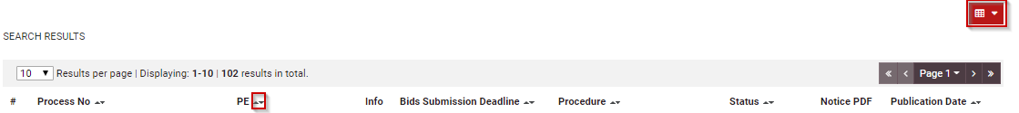

Figure 1: Example of a table header

The arrows  are used for sorting (in ascending/descending order) the results by the corresponding field. The button  is used to hide/ show a number of fields in the table.

Any search query or list, with more than a page of results, will include the following navigation buttons:

Table 1: Pagination options

|  |  |
| --- | --- |
|  | First Page |
|  | Last Page |
|  | Previous Page |
|  | Next Page |

The following buttons are also widely used within the e-GP:

Table 2: Additional options

|  |  |
| --- | --- |
|  | **Calendar Button**. Selecting this button opens a calendar enabling the user to select a date |
|  | **Search Button**. Selecting this button opens a searching window enabling the user to search for various codes (e.g. UNSPSC codes) |
|  | **Clear/Remove Button**. This button clears the selection of the user |

## The Process Menu Functionality

The data uploaded or produced by the system within the context of a Process is categorised depending on context. The Process Menu contains all available options for accessing these various categories of a Process, depending on the user role. It comprises the main navigational tool of a Process. The Process Menu is collapsed by default:



Figure 2: The Process Menu (collapsed)

If the user selects the Process Menu, it will be expanded to show all available functionalities. The user can select any of the provided functionalities:

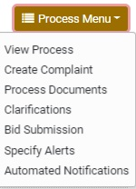

Figure 3: The Process Menu (expanded)

Selecting the Process Menu, again, will collapse it (Figure 2).

## Main Page

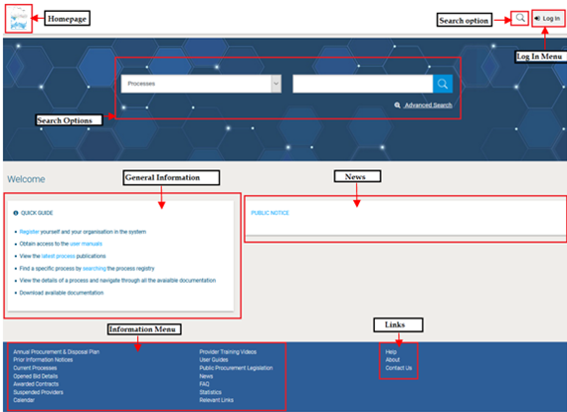

Figure 4: Main page

The main page of the e-GP system consists of the following elements:

**Top column**, which contains the Login panel, Homepage Panel and Search option Panel.

**Central column,** which contains general information regarding the system, the Providers and the users of procuring entities. Furthermore, it lists any uploaded news and also statistical information about the system usage.

**Bottom column,** which contains the Information menu panel, helpful links and functionalities which are available within all pages of e-GP.

The following are the most important sections within the main page.

### Login Section

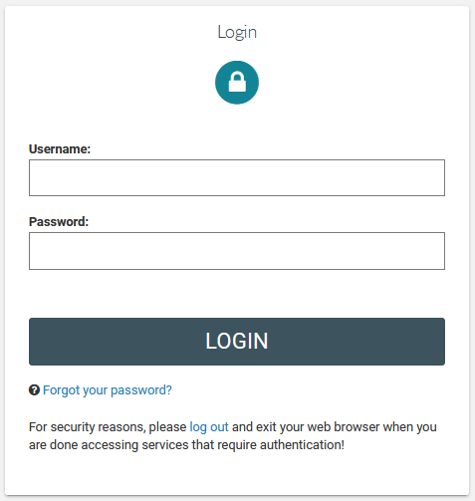

Figure 5: Login panel

In this section, functionality is provided to enable all users (Procuring Entities, Provider Organisations and Administrators) to authenticate in the system providing that they use correct credentials (username and password).

### Search Section

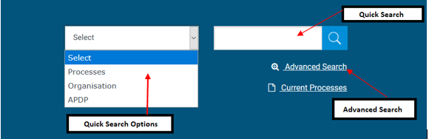

Figure 6: Search panel

The users can use this section to search for Processes, Organisations and Annual Procurement Disposal Plan entries. Advanced searching functionality, (by selecting the button) is also provided (Figure 6).

## Login to the System

All users of the e-GP module should have an appropriate user name and password. In order for a user to login to the system, he must provide his credentials in the login section of the main page.



Figure 7: User login

If the user provides incorrect credentials (either user name or password) an error message will be displayed, informing the user regarding the remaining failed attempts:

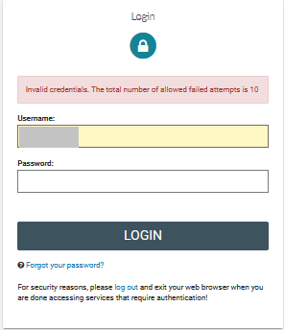

Figure 8: Wrong credentials

If the user provides an incorrect password for a username more than 10 times, his account will be temporally locked and a message will be displayed.



## Login to the System for the First Time

The following steps are available, when the user logs in to access the e-GP services for the first time.

As a first step, the user will have to provide the transaction number (which is received by email after his successful registration on the system).

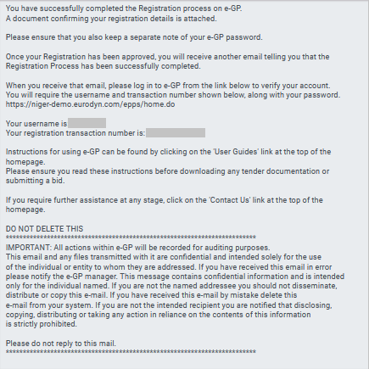

Figure 9: Confirmation email received during registration.

After providing his user credentials the user is requested to provide the transaction number received during the registration.

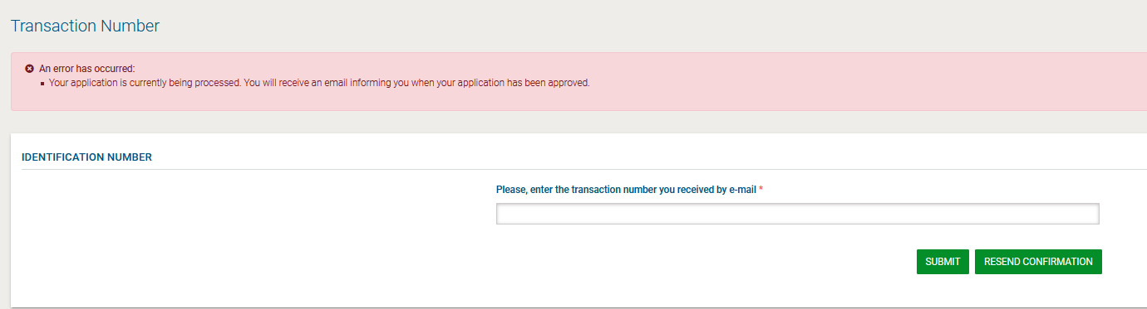

Figure 10: The transaction number

If the user has misplaced the e-mail with the transaction number, it can be resent to the registered e-mail address by clicking on the  button.

Then, the user is prompted to read and accept the following System User Agreement.

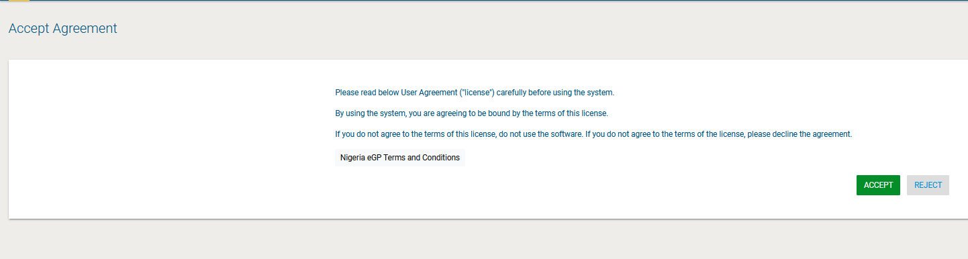

Figure 11: Confirmation of the user agreement

Finally, the Provider accepts the Agreement, he will be asked to change his password.  
  
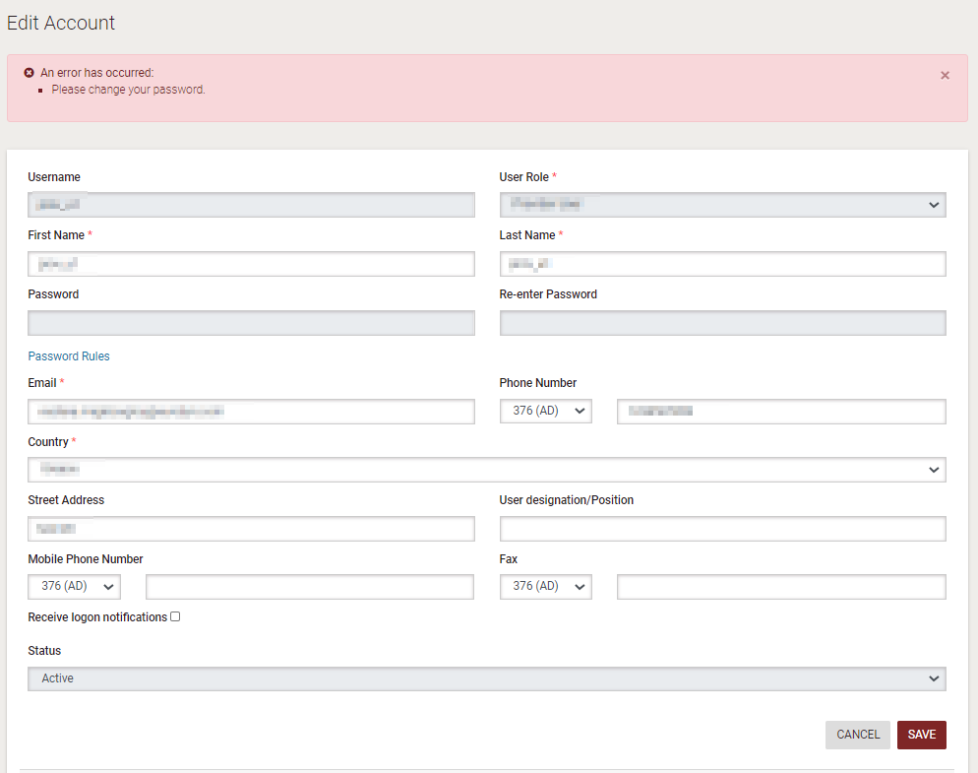

Figure 12: Change your password functionality

## Logout from the System

The user can exit the e-GP services by selecting the “**Log out**” functionality.

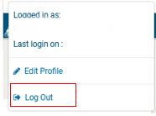

Figure 13: Log out functionality

## Password Recovery

The user can recover his password from the “**Forgot your password**” functionality (Figure 5) available at the home page.

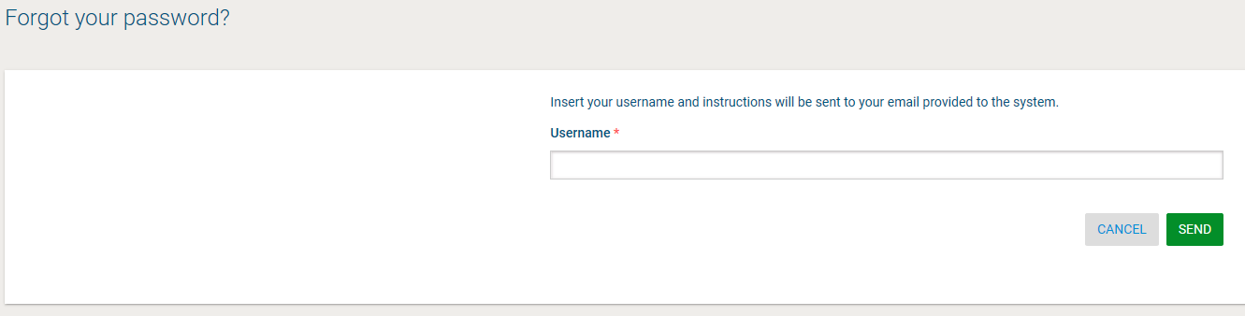

Figure 14: Password recovery/change

If the provided details are valid, the system sends an email to the associated email address, containing a transaction number and a unique generated access link.

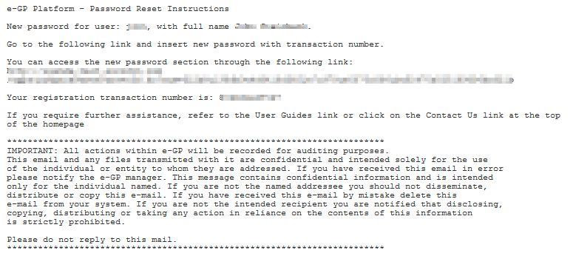

Figure 15: Email containing a registration transaction and unique access link

In order to reset the password, the user accesses the displayed link. To trigger the password reset functionality, the system requires the user to provide:

Username

New password

Password confirmation

Transaction number

Secret answer

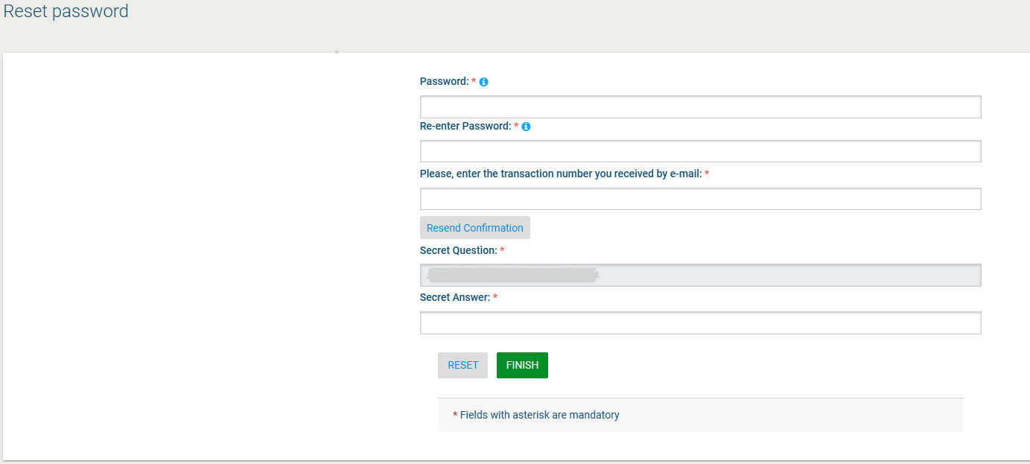

Figure 16: Resetting the password

## Maintenance of User’s Profile

After successful authentication the user can edit their profile by selecting the “**Edit Profile**” functionality (accessible in the right column menu). The user can update the information fields and then select the button “**Save**” to store the performed modifications. In case any of the mandatory information is missing the system will prompt the user to try again with an error message.

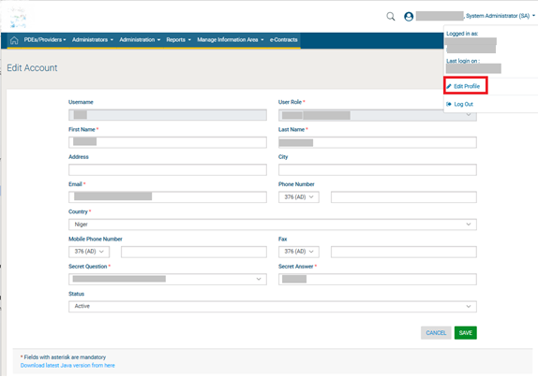

Figure 17: Edit User’s Profile

The password should follow a specific configuration. To view the password rules the user should click on the link “**Password Rules**” (Figure 18). The password configuration rules consist of:

Letters (upper case/lower case) allowed to be used

Numbers allowed to be used

Characters allowed to be used

Allowed login failures

Password lifetime

Password length (min/max)

Password history

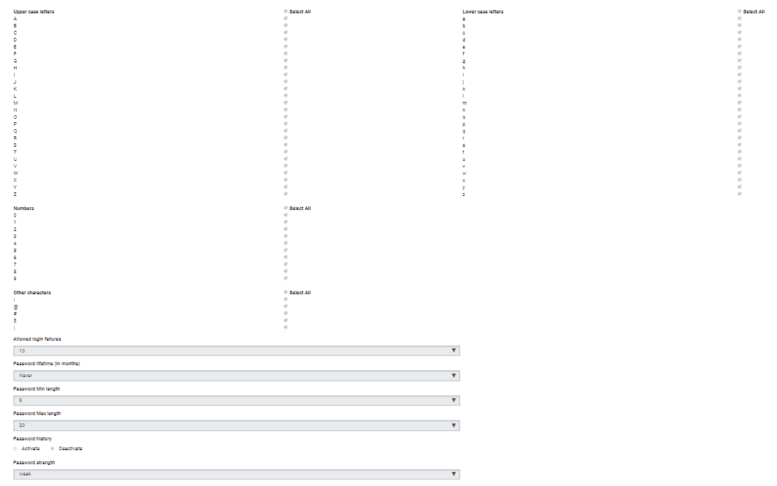

Figure 18: Password Configuration Rules

In case the password does not follow the password configuration the following message appears.



## XLS File Format Support

All XLS files uploaded to the e-GP system must abide to the Microsoft Office Excel 2003 format.

|  |  |
| --- | --- |
| MC900432547[1] | All XLS files must abide to the Microsoft Office Excel 2003 format.  Users that have later versions should save their files in 2003 format (Save as type and select the option “Excel 97-2003 Workbook”). |
|  |  |
|  |  |

## Registration of a Provider Organisation

All Providers are able to self-register to use the e-GP system.

### Online Provider Registration

In order for a Provider to register in the system, they should select the option “**Register yourself and your organisation in the system**” on the left of the e-GP’s main page (Figure 19).

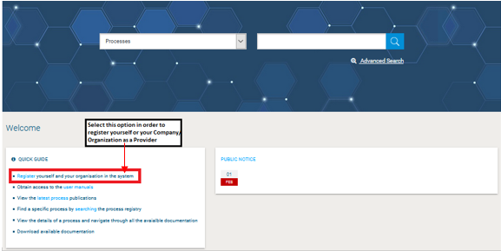

Figure 19: Register as Provider

In the first phase of the registration process the user selects his “Provider Type” among Provider Organisation and Individual Provider (Figure 19).

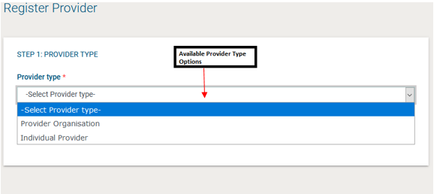

Figure 20: Provider registration

If the user registers his organisation he should provide the following information (Figure 20):

For foreign providers, all details need to be entered manually. In particular, the registration forms will contain the following fields:

the Provider Organisations:

**“**Date of incorporation / Registration”

“Country of incorporation/ Registration”

“Provider Registration Number”

“Provider Registered Name”

“Organisation Type”

“Tax Identification Number (TIN)”

“Street Address”

When selecting “Joint Venture/Consortium / Association” in the “Organization type” field, the following fields will be added:

“Lead Partner:”

“Partners”

Fields for all types of Provider Organizations:

“PO Box

“Postal Code”

“City”

“Country”

“Latitude”

“Longitude”

“Phone number 1”

“Phone number 2”

“Business sector”

“Subsector”

“Certificate of Incorporation/Registration”

“Trading License/Business Operating License”

“Proof of Tax Registration”

“Small scale enterprise”

“Proof of small scale enterprise”

“Other Attachments”

“URSB status”

“Website address”

“Email address”

“Type of Activity”

“CAPTCHA”

“Director Details”

“Name” (text)

“Position” (text)

“E-Mail Address” (text)

“Telephone” (text)

In order to proceed to the next phase, the user should have also typed, in the provided text field, the visual **CAPTCHA** code displayed by the system on the screen. Selecting the “**Refresh**” button  updates the code (Figure 20). Finally, the user should select the button “**Validate & Continue**” to continue the registration process.

If the user registers as Individual Provider they should provide at least the following information (Figure 22). Finally, the user should select the button “**Validate & Continue**” to continue the registration process.

“Full Name”

“Tax Identification Number (TIN)”

“National Identification Number/Passport Number”

“Street Address”

“PO Box”

“Postal Code”

“City”

“Country”

“Latitude”

“Longitude”

“Phone number 1”

“Phone number 2”

“Business Sector”

“Subsector”

“Copy of National Id/Passport”

“Copy of TIN Certificate”

“Small scale enterprise”

“Proof of small scale enterprise”

“Other Attachment”

“Website address”

“Email address”

“Type of Activity”

“CAPTCHA”

A Provider Organisation will be uniquely identified by the combination of its TIN and Provider Registration Number.

It is the responsibility of IFMIS to match the TIN of the provider against existing records to determine whether to create the provider or not.

If the user registers as PDE Organization - Provider they should provide at least the following information .Finally, the user should select the button “**Validate & Continue**” to continue the registration process.

a PDE organisation:

“PDE Name”

”PDE Code”

“PDE Type”

“PDE logo”

“Has Parent”

“Parent Entity”

”Street Address”

“PO Box”

”Postal Code”

“District”

”City” field

”Country” field

“Latitude”

“Longitude”

”Email” field

”Phone Number 1”

”Phone Number 2”

”Fax”

”Website”

“CAPTCHA”

Figure 21: Individual Provider Registration

The next step during the Provider’s Registration is the “Register Director Details”.

The next step is the definition of the Director details of the organisation . The user add up to 10 directors by the use of the 2018-09-24 14_43_30-GHANEPS - Register Director Details button. The button 2018-09-24 14_44_01-GHANEPS - Register Director Details is used to delete an already existing director. At least 1 Director must be added during the registration process.

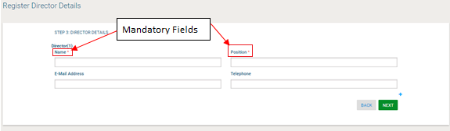

Figure 21: Directors Registration

The next step (optional) for both provider types is the association of UNSPSC codes of interest with the organisation. The user can associate UNSPSC codes by the use of the  button. The button  is used to delete a selected UNSPSC code.

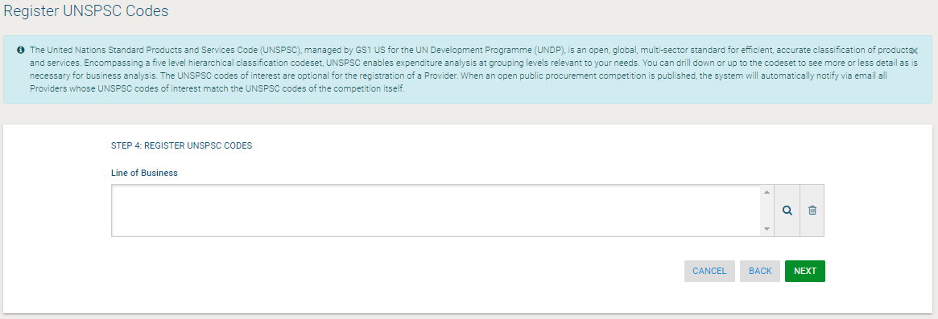

Figure 23: Registration of UNSPSC codes

After clicking on the  button, the user is presented with a pop-up window to select UNSPSC codes.

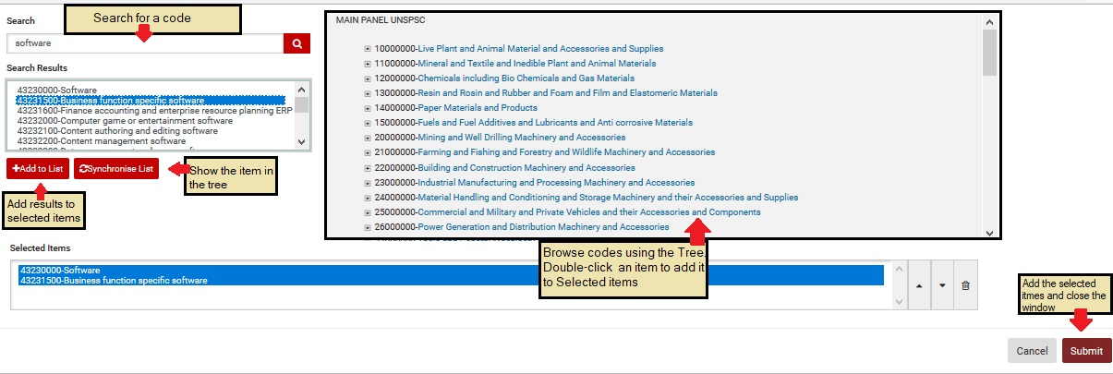

Figure 24: UNSPSC code selection

In order to continue, the user should select the “**Next**” button. The “**Back**” button returns the user to the previous phase.

In the final step the user registers the administrator of the Provider Organization (Provider Administrator user):

First Name

Last Name

Username

Email

Password

Re-enter Password

Street Address

Country

Phone Number

Mobile Phone Number

Fax

User designation/Position

Receive logon notifications

Receive SMS notifications

Secret Question

Secret Answer

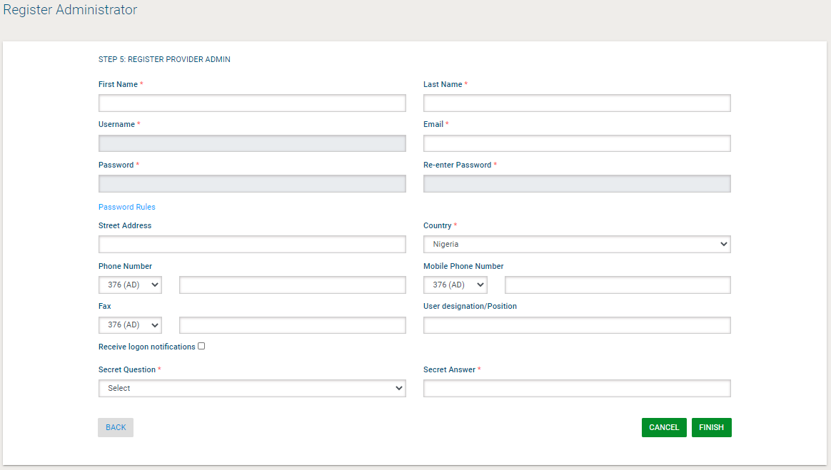

Figure 25: Registration of a Provider Administrator user

In order to finalise the registration process, the user selects the “**Finish**” button. A message confirming the successful registration of the Provider will be displayed.



Figure 26: Confirmation of successful registration of the Provider

The system will send an email to the user containing details of how to access the system.

The registration of a Provider needs to be validated by the System Administrator.

However, before the Provider Approver can validate the Provider registration, the registration fee needs to be paid by the provider. After logging in for the first time, the user must view the provider profile and must complete the payment of the required fee.

If the warning message continues to occur after the registration fee has been paid, please contact the Provider Approver, in order to activate the organisation account.

### Payment of Fees

The e-GP system supports online payment through the State e-payment portal. When the Provider registration fee (or annual registration renewal fee) is due for payment.

The providers will have to select one or more of the following categories to be registered:

• Supplies

• Consultancy or Non-Consultancy Services

• Works

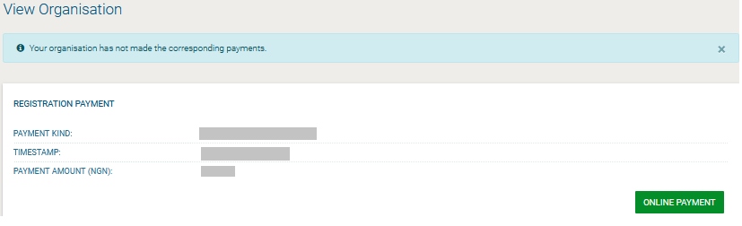

Figure 28: Provider registration fee

After clicking on the “Proceed to Payment” button to initiate the process, the user is transferred to the Government's payment portal where the payment is already placed within his/her cart, internet banking or mobile money.

In case of small scale enterprises, the SA user will be responsible to review the “Proof of small scale enterprise” attachment before activating the provider account.

## Provider Management

The Users with the role of Provider Organisation Administrator can perform the following activities for the management of their organisation:

Edit organisation details

View the users registered within the Provider organisation

Edit the UNSPSC codes registered for the Provider

Add new users to the Provider organisation

Edit user’s details

Export Auditing Reports

This management functionality is provided through the “**Provider Management**” option of the “**Provider Administration**” menu.

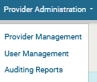

Figure 21: Provider menu

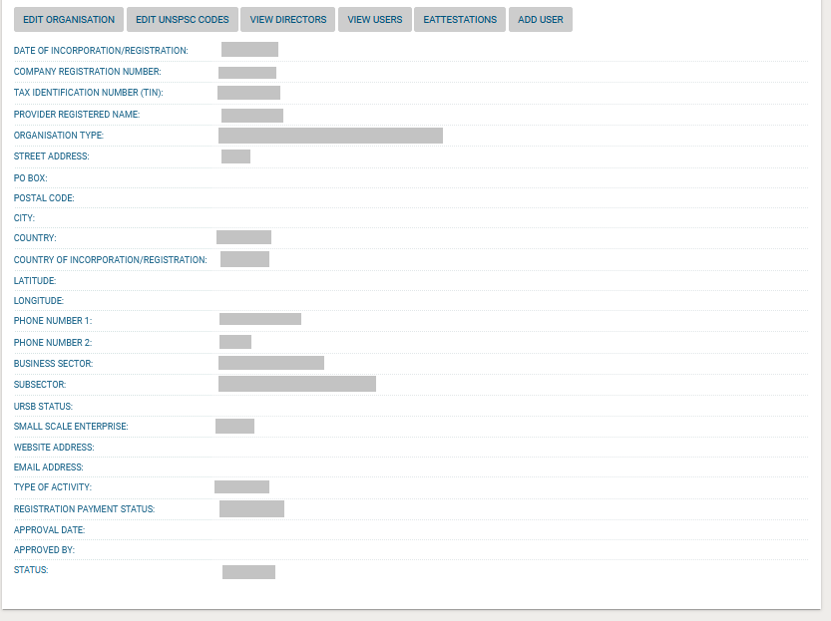

Figure 22: Provider Management functionality

### Edit Organisation Details

Selecting the option “**Edit Organisation**” allows the user to edit the organisation’s details. After the edit of the details of the Organization, the status of the organization will be automatically reverted to “Pending” and the modifications will have to be accepted.

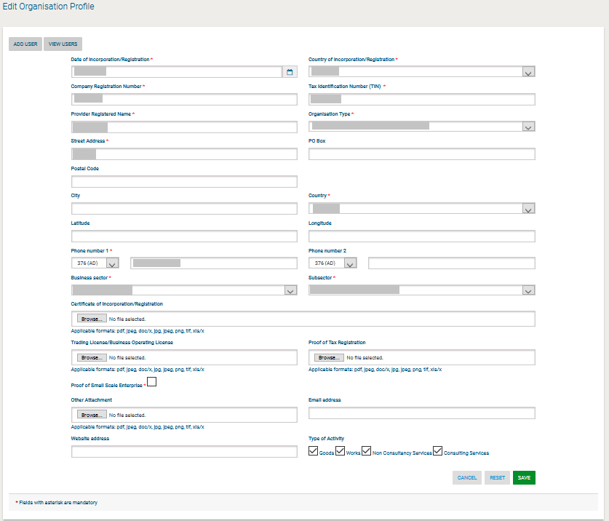

Figure 23: Editing Provider details

Selecting the button “**Save**” will store the performed modifications, while the “**Reset**” button will reset the performed modifications.



Figure 24: Organisation details were successfully updated

### Add New User to the Provider Organisation

In order to insert new users into the organisation, the Provider Administrator needs to select the option “Add user”. The mandatory information below must be provided.

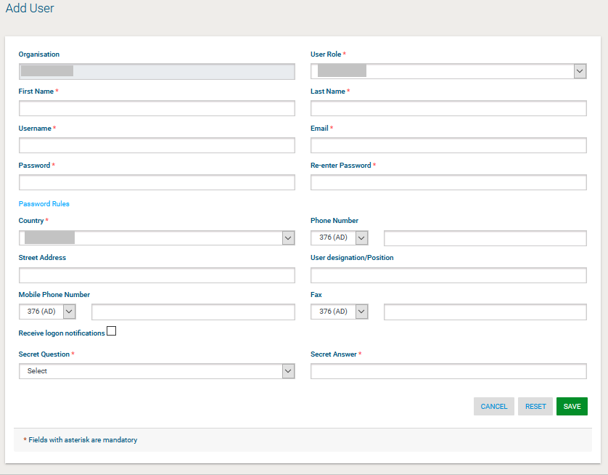

Figure 36: Insert a new user in the organisation

Initially, the account of the new user will be Inactive. The system will send an email to the new user confirming the successful registration. The email will contain the relevant transaction number. In order to activate his account the user must provide this number during their first login. Thereafter, the status of the account will be set to active.

### View the Users Belonging to the Provider

Selecting the option “**View Users**” displays all the users registered within the selected Provider organisation.

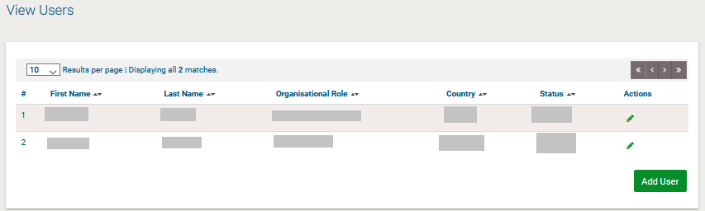

Figure 37: Display of users belonging to the Provider.

In the above screen, the first name, last name and the role of each user are displayed. Furthermore, the current status of the each user account is also displayed.

The following user roles are supported:

Provider Administrator (**Provider Admin**). Users with this type of role are authorised to manage the users and update the details of their organisation.

Provider users (**Provider Users**). Users with this type of role are not authorised to manage the details and the users of their organisation

### Edit User’s Details

The user can select the option “**Edit Account**” to edit the details of a specific user. The system will display all user details allowing their modification (**Error! Reference source not found.**).

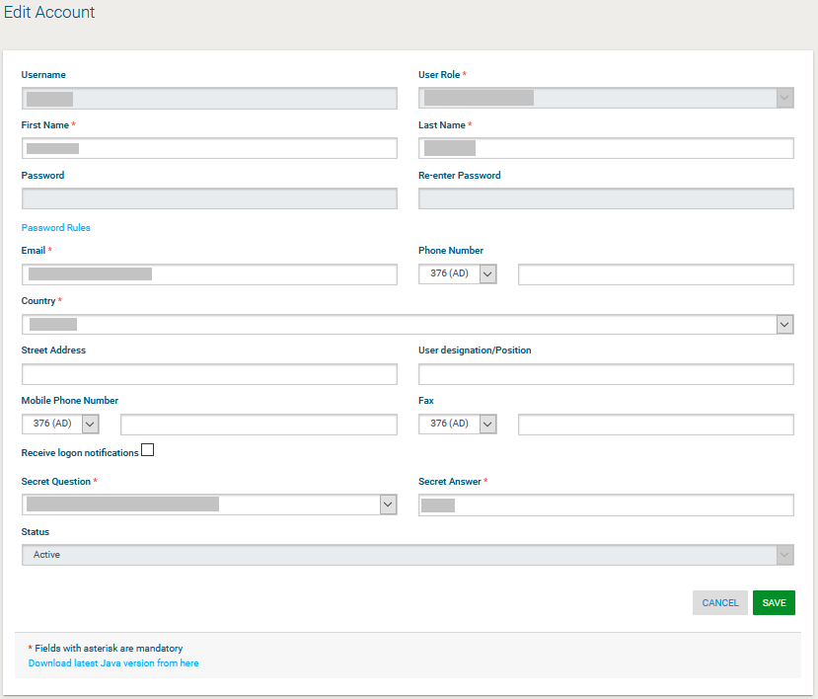

Figure 25: Editing user details

Selecting the button “**Save**” will update the user’s details (Figure 25).

### Logon Notifications

A user can choose to be notified by e-mail whenever their credentials are used to login to the e-GP system. This is accomplished on the Edit Profile page by selecting the checkbox to enable logon notifications.

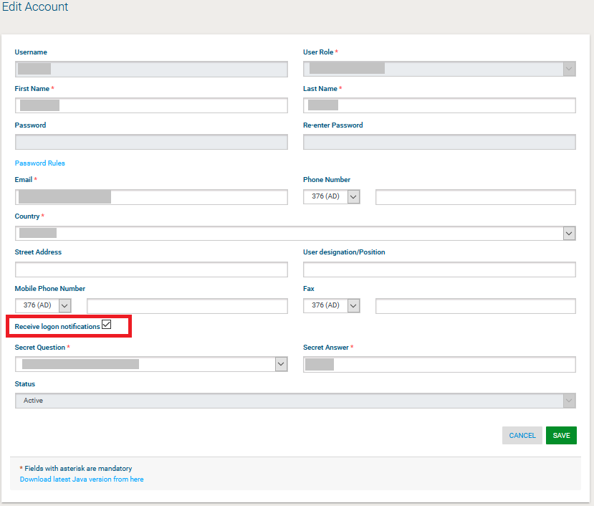

Figure 26: Logon notifications

If the logon notifications are enabled/disabled by an administrator user and not by the individual user, the user receives an e-mail notification that their profile has been modified.

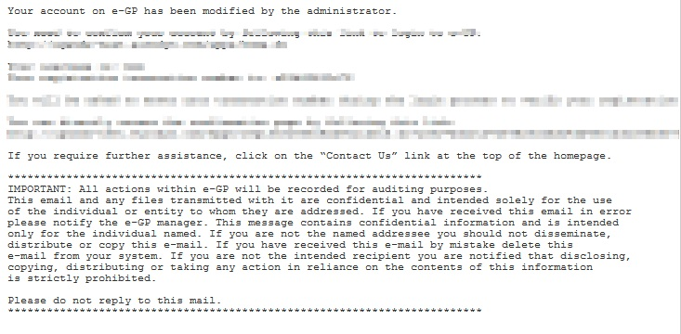

Figure 40: Logon notifications administrator action confirmation e-mail

When logon notifications are activated, each time the user’s credentials are used to login to e-GP, an e-mail notification is sent to the registered e-mail address of the user.

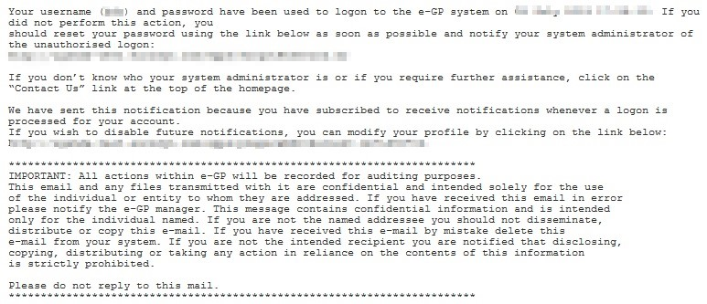

Figure 27: Logon notification e-mail

### Edit UNSPSC Codes

In order to edit the UNSPSC codes associated with the Provider the user selects the “**Edit UNSPSC Codes**” option in Provider Organisation management page (Figure 22). The system displays the UNSPSC codes which are currently associated with the Provider (if any).

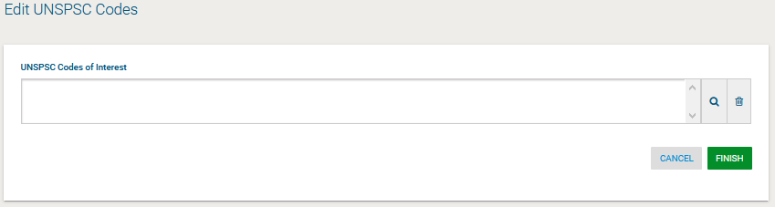

Figure 28: Edit UNSPSC codes

The user can add new UNSPSC codes by the use of the  button. The  button is used to delete a selected UNSPSC code.

After modifying the associated UNSPSC codes (Figure 28), the user can select the “**Finish**” button to store the changes.

## Searching Functionality

The e-GP system provides both simple and advanced search mechanisms. Both functionalities allow searching for Processes, Organisations and Annual Procurement and Disposal Plan entries.

### Simple Search

The simple search functionality covers searching for available Processes, registered Organisations and published Annual Procurement and Disposal Plan entries.

Simple search queries are performed by:

Selecting the type of searching (Processes, Organisations or Plans) from the selection list.

Providing the full name of the required record or part of it using the “\*” wildcard.

Selecting the button “**Search”.**

The results, if any, are then presented in a tabular form.

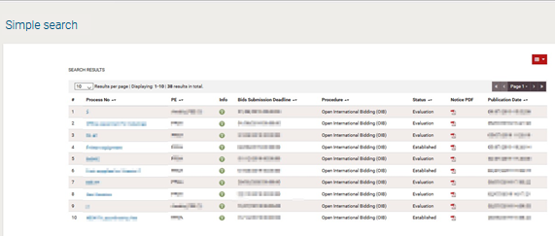

Figure 29: Simple search for processes

### Advanced Search

The advanced search functionality enables searching for Processes, Organisations and Annual Procurement and Disposal Plan entries. In order to perform an advanced search query, the user should:

Select the type of the search by using the appropriate button

Provide information in one or more fields (use of \* wildcard is also enabled).

Select the button “**Search”**

For further information on each criterion select the respective info icon 

The results, if any, will be presented in a tabular form.

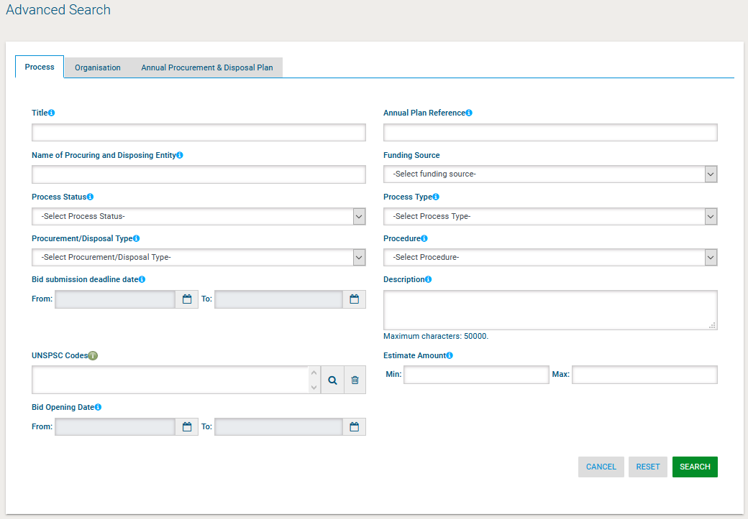

Figure 30: Advanced search for a process

A Provider user can only search for Procuring and Disposing entities when searching for Organisations and cannot search for other Provider organisations. Figure 31 provides an example of a search query for Procuring and Disposing Entities.

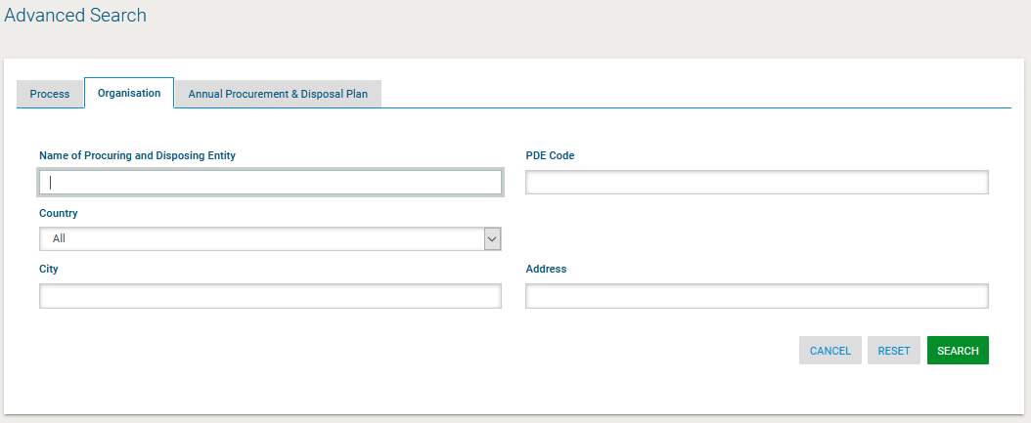

Figure 31: Advanced search for a Procuring and Disposing Entity

Annual procurement and disposal plan entries can be filtered by any combination of the publication date, the procurement type, the procurement or disposal method, the UNSPSC code or the procuring and disposing entity.

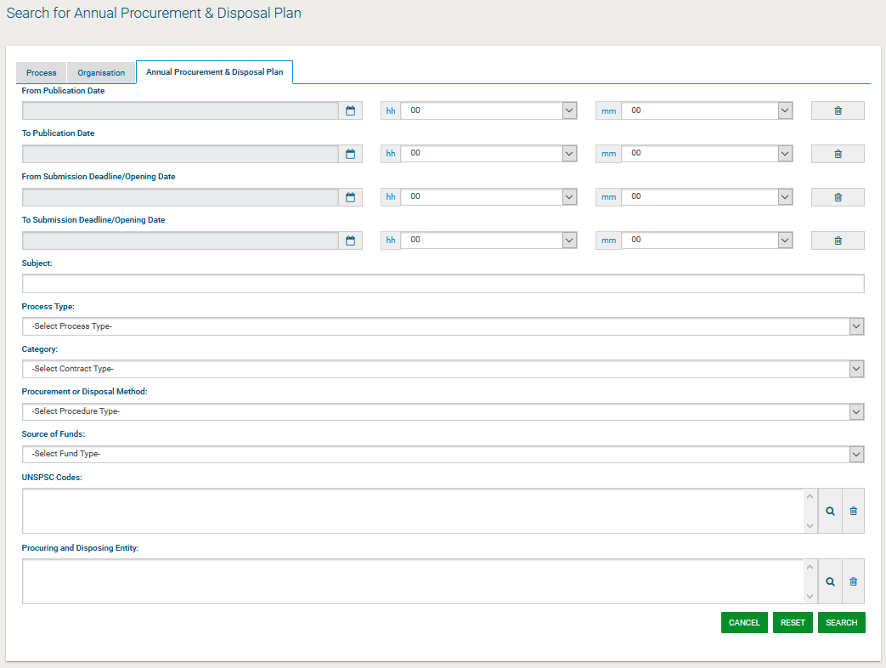

Figure 32: Advanced search for an annual procurement & disposal plan entry

### Current Processes Search

In order to view the current Processes published within the service, the user can click on the “Current Processes”, as depicted in Figure 33. This will present automatically the list of the current processes that are available to the user (depending on his/her access rights).

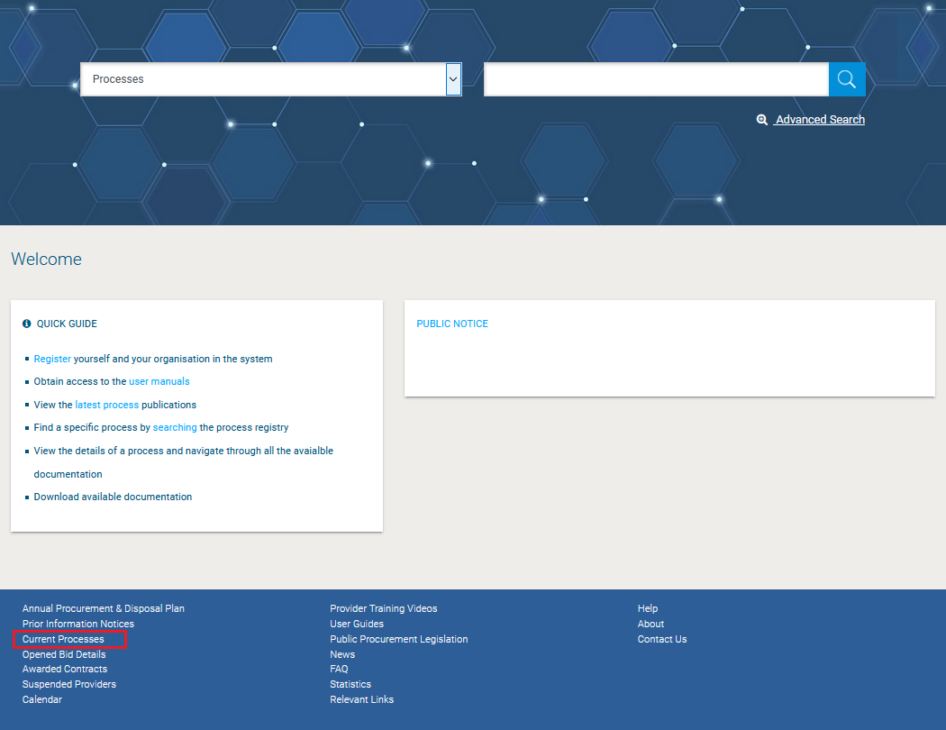

Figure 33: Current Processes search

## Process Workspace

### View Process Workspace

In order for the user to preview the details of the Process they need to select the option “**View Process**” from the **Process Menu** (Figure 34).

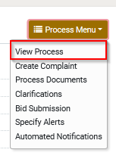

Figure 34: Process Menu

The system will display all details (Figure 35) of the particular Process (e.g. Title, information regarding associated deadlines, etc.).

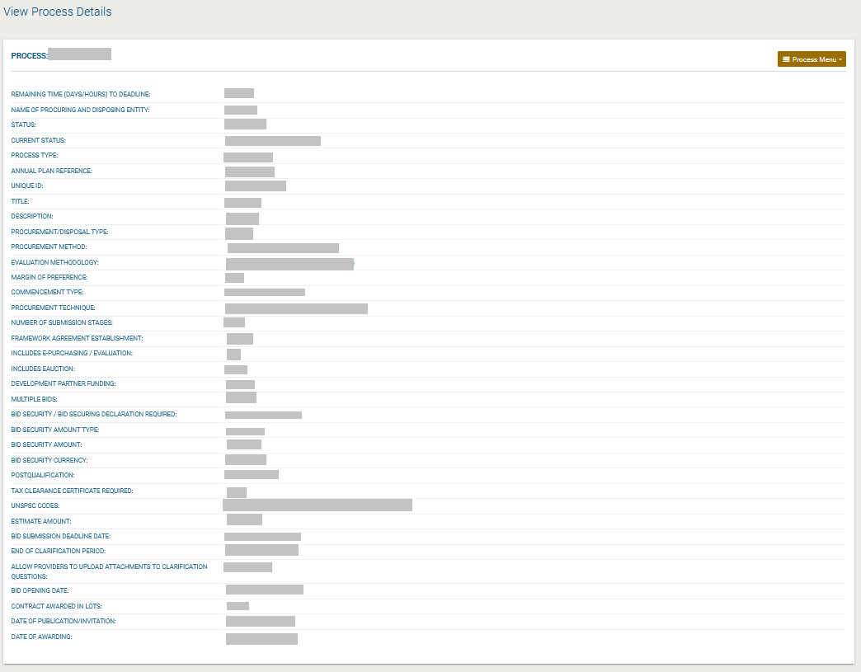

Figure 35: View Process Details

### View Process Documents

In order for the user to preview and download all documents associated with the particular Process (i.e. publication notices being published for this process), he needs to select the option “**Process Documents**” from the **Process Menu** (Figure 34).

The system displays all process documents which are associated with the Process.

The Notices (Figure 36) associated are available in this menu, also the “**Process Documents**” tab (Figure 37) (that can be downloaded in a compressed file by clicking the “Download Zip File” button.), contain a list of all documentation created by the procuring and disposing entity that is related to the specific Process.

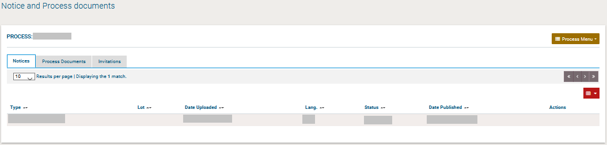

Figure 36: Notices Section

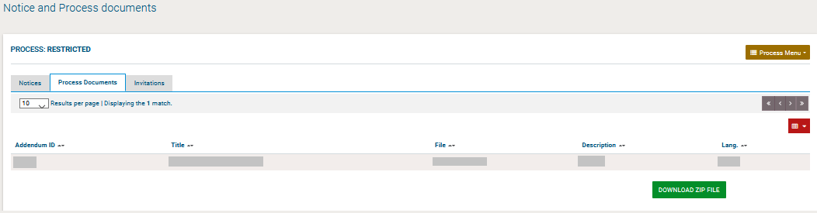

Figure 37: Process documents section

From the “Invitations” tab, the user can view the details of the invitations dispatched by the buying organisation.

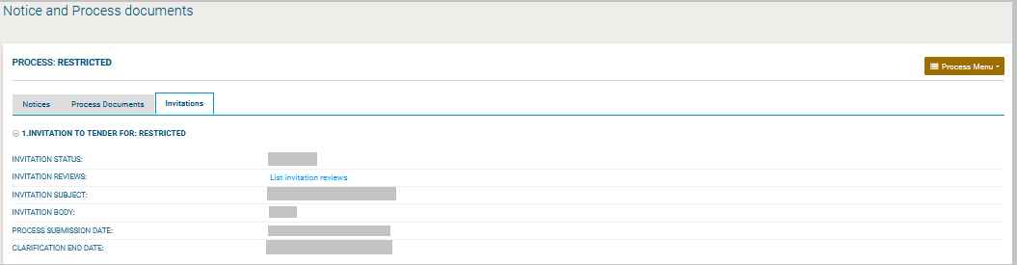

Figure 38: Invitations

### Clarifications

In order to create a clarification request and to preview a clarification response, the user needs to select the option “**Clarifications**” from the “**Process Menu**” (Figure 39). This option is available in the “**Process Menu**”, during the clarification period.

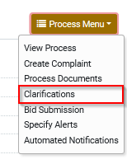

Figure 39: Process Menu, option “Clarifications”

#### Create a Clarification Request

In order to create a clarification request, the user selects the “**Requests for Clarification**” tab from the main Clarifications page (Figure 40).

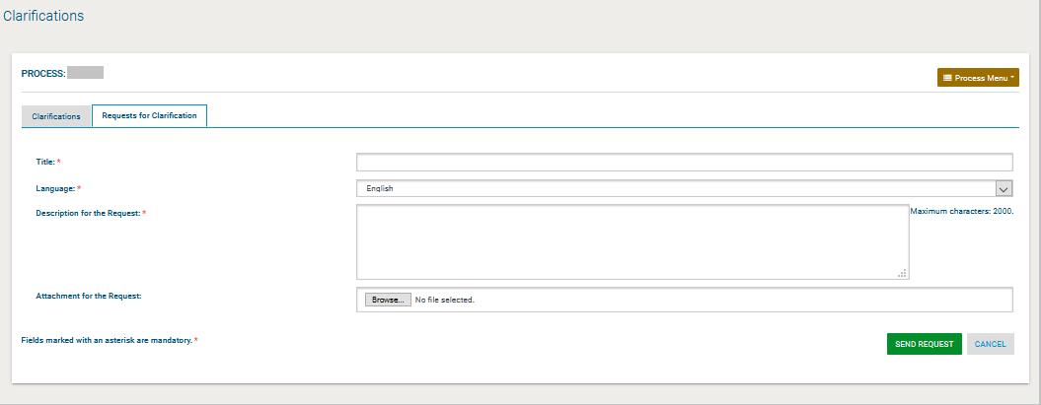

Figure 40: Process Clarifications

The user completes the request for clarification by providing the following information:

Title

Language

Description for the request

Selecting the button “**Send Request**” sends the request to the process coordinator.

#### View a Clarification Response

The user can view a clarification response only after it is published by the Procurement Coordinator. A list of all clarification responses is displayed in the “**Clarifications**” tab of the main Clarifications page.

In order to preview the content of the response, the user selects the displayed title. Then, the system expands the details of the response (Figure 41):

Description for the request

Procurement Coordinator’s clarification response

Attachment (if exists)

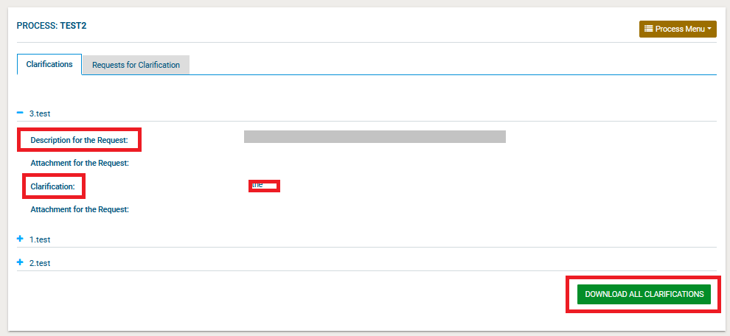

Figure 41: Response to a clarification request

Selecting the button “**Download All Clarifications**” enables the user to download an archive file with the details of all clarification requests submitted and their associated responses.

### Evaluation Clarifications

Evaluation clarifications are requests submitted by the Procuring and Disposing Entity in the context of a specific Process during the evaluation phase. To preview any evaluation clarification request the user needs to select the “Clarifications” option found under the Process menu (Figure 39). By selecting the “Evaluation Clarifications” tab, a list of all the evaluation clarifications is displayed (Figure 42).

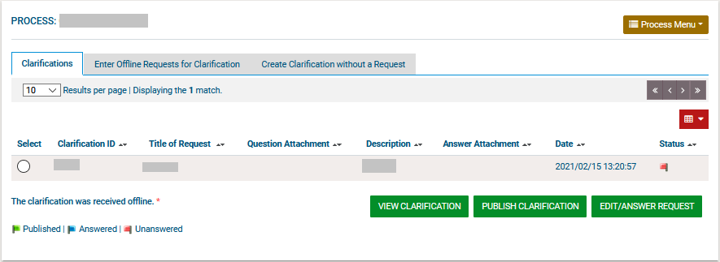

Figure 42: List of evaluation clarification requests

The user can answer to the clarification request by selecting “**Answer Clarification Request**”. The user completes the clarification by providing his response in the “**Clarifications**” text area.

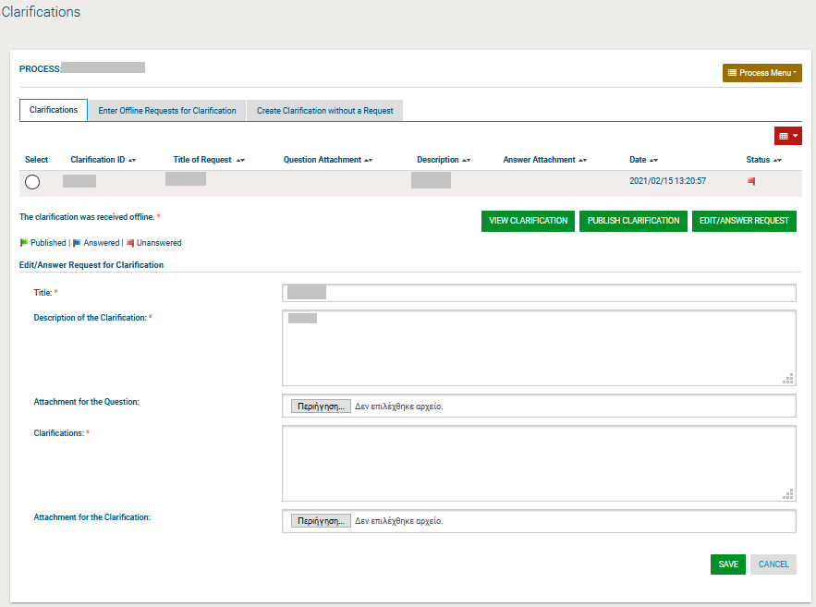

Figure 43: Evaluation clarification response

## Creation of a Bid

The bid is created by the Provider following a sequence of steps described below that enable the user to prepare and securely upload the bid to the e-GP system. A Provider may submit a bid via online means, or send it offline to the Procuring and Disposing Entity. The latter approach, however, is highly discouraged if the benefits of the e-GP system are to be fully exploited.

### Participation Fee

In case of Bids that include a participation fee, the user will need to complete a payment before they can be allowed to upload a Bid.

In case of multi-stage procedures, if there is a “participation fee”, any Provider that will pay for Bid submission during stage 1, will not be required to pay again for Bid submission in stage 2.

### Prepare Online Bid

Once a Bid Notice is published by a procuring and disposal entity regarding a specific Process, the provider user that intends to submit a bid may proceed to create a valid bid for the e-GP system in two manners. Either create an online bid or create an offline one. This section describes the process for creating an online bid, through the steps in the following paragraphs.

#### Online Bid Preparation Tool

The provider first should find the Process, that he is interested in. (see 2.12.3)

Click on the “Bid submission” option of the Process Menu (Figure 44).

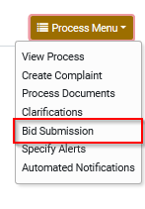

Figure 44: Bid submission option of the Process menu

The first time the bid submission section is accessed, after the user defines the type of association, they have to accept the Provider Declaration (Accept Agreement for this Process) and confirm that their details are correct by clicking on the “**Accept & Confirm all of the above**” button (Figure 45).

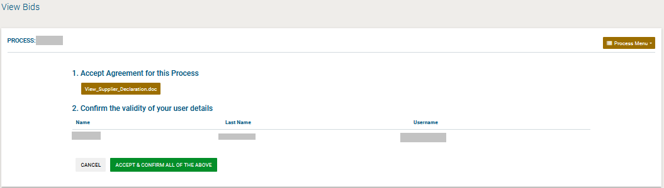

Figure 45: Provider declaration acceptance

After paying the bid participation fee, if applicable, the user will see the web bid preparation tool in their browser (Figure 46).

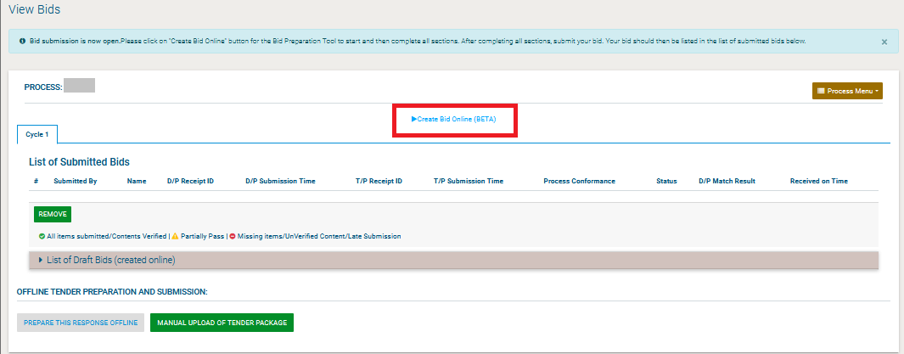

Figure 46: Online bid creation

#### Provider Responses to Bid Questions

After Selecting the “Create Bid Online” Button, the user is redirected to a new page, where they will have to create a Response for the specific Bid.

Figure 47: Provide Response’s Title

After providing the Title of the response, the user will see the following screen, in order to start editing the bid and completing all the necessary fields.

When the user wants to start completing the fields of their bid, they should select the following option, on the top right part of the screen:

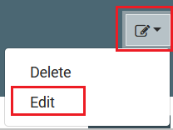

Figure 48: Edit Bid

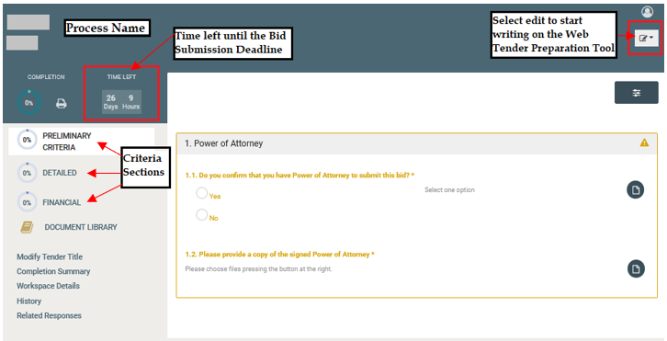

Figure 49: Online Bid Submission Tool Preliminary Criteria – example Completed Detailed Criteria

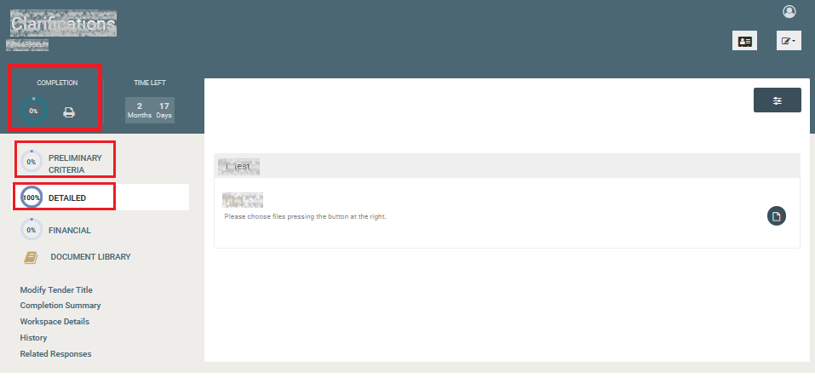

Figure 50: Online Bid Submission Tool Detailed Criteria – example Completed Preliminary and Detailed Criteria

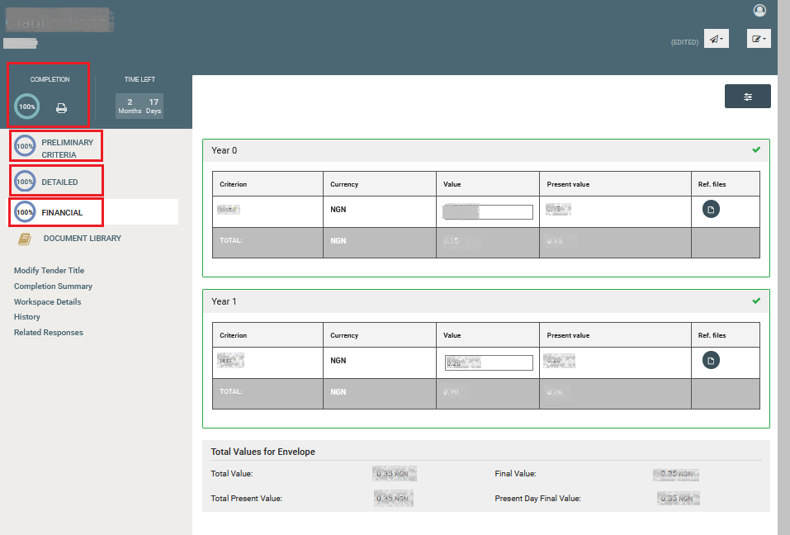

Figure 51: Online Bid Submission Tool Financial Criteria – example all Criteria completed

#### Submit a Bid

Once the user has completed its bid to its totality (i.e. Completion is at 100%), the user should click the option “Submit”. This file cannot be unlocked and/or viewed by anyone. It will be unlocked only when the Openers (OP) authorise the unlocking of all bids after the end of the bid submission period.

The user should proceed to complete all criteria included in the Preliminary, Detailed and Financial Envelopes. Once the user completes some data, even if not all of them, the system saves automatically all these data as draft. This can be seen in the following section:

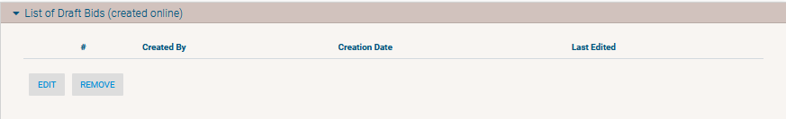

Figure 52: List of Draft Bids

Once all Folders are completed, the user should select the “Submit” option, from the top right button:

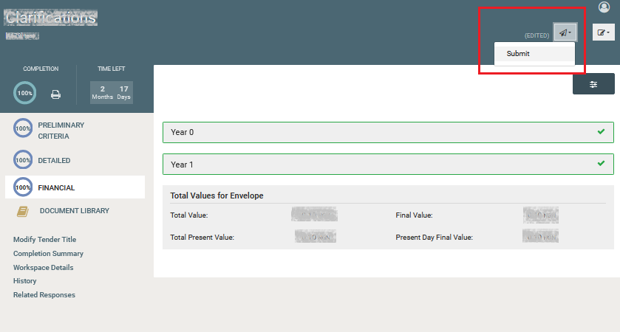

Figure 53: Bid to be submitted

After the submission, the status will be “Submitted” as in the following picture:



Figure 54: Status of the Bid Submission is > Submitted

If the submission is completed, the user will be able to see information of the submission such as:

Submitted By

Name

D/P Receipt ID

D/P Submission Time

T/P Receipt ID

T/P Submission Time

Process Conformance

Status

D/P Match Result

Received on Time

This information will be seen under the “List of Submitted Bids” of the “Bid Submission” menu, as seen below:

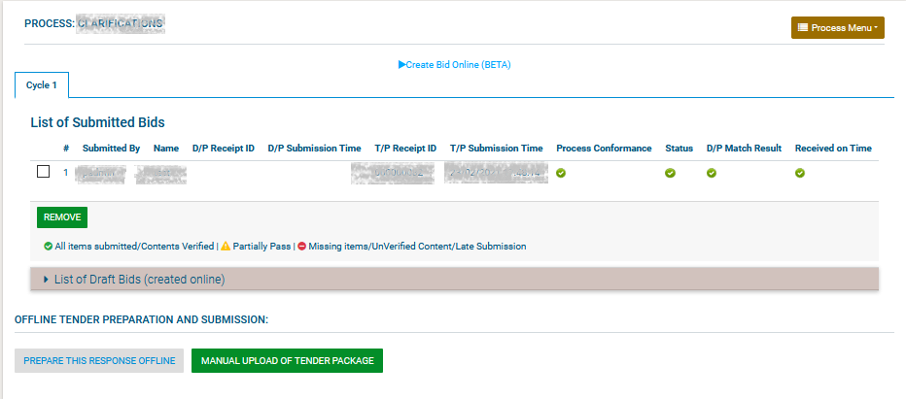

Figure 55: List of Submitted Bids menu

#### Management of a Bid

Until the bid submission deadline is reached, a provider has the right to remove an already submitted bid by selecting the bid and clicking the “Remove” button (Figure 55). If a submitted bid is removed, up until the bid submission deadline, the provider retains the right to upload a new bid, by following the steps described above.

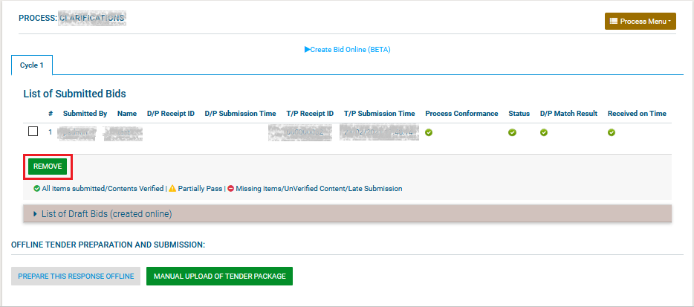

Figure 56: Remove already submitted bid

Under no circumstances can the provider download a submitted bid from the system and then open it in order to see the files uploaded. As aforementioned, a submitted bid is an encrypted file that the system is not authorised to decrypt until the bid submission deadline has passed and the opening staff have instructed the system to proceed to unlocking.

#### Financial Response in case of Framework Agreements

The Provider will be required to fill in all mandatory criteria; particularly for the financial criteria, then, the Provider must upload the relevant Price Schedule in order for the Bid to be properly filled-in.

In case of Lots and Procurement Lot specification is “one lot only” or “one or more lots”, the Provider will need to select the Lots that he is interested in and fill in the respective criteria, along with the associated financial values and Price Schedule information. In contrast, in case of Lots and Process Lot specification is “all lots”, the Provider will need to place an offer for all lots.

Apart from the Price Schedule file itself, the user will be able to upload an additional archived file (i.e. ZIP) including images or other documentation associated with Price Schedule items

In case a Price Schedule that is not in accordance with the specifications, the Bid preparation tool upon processing of the uploaded Price Schedule will produce an error report.

### Offline Bid Preparation Tool

In this context, an offline bid means an electronic bid prepared while not connected to the Internet and does not mean a paper-based response to the process. The preparation of an offline bid follows a very similar process to the online one. In particular, after having accessed the bids page, the user should NOT click on the “Create Bid Online (BETA)” link. Instead, the user should download the Evaluation Criteria and the Preparation Tool by clicking on “Prepare this response offline”. The user can disconnect from the Internet once the file has been successfully downloaded.

The downloaded file is a zip file (named TPTandC4TXML.zip by default) containing both the Process Preparation Tool (in a zip archive) as well as the process questions in an XML file. The initial zip file must be de-compressed into a local folder on the end-user PC. The Preparation Tool is a zip file that the user should also de-compress into a local directory. After de-compression, the tool should be started using the file named “TenderPreparationTool.exe”. Once the tool is started, the user should click on the “open” option and open the XML file forming the Evaluation Criteria of the Process. All the rest of the steps for bid preparation are identical to the online part.

Once all questions have been answered and the bid has been saved, the bid should be encrypted using the “Pack” button (Figure 57).

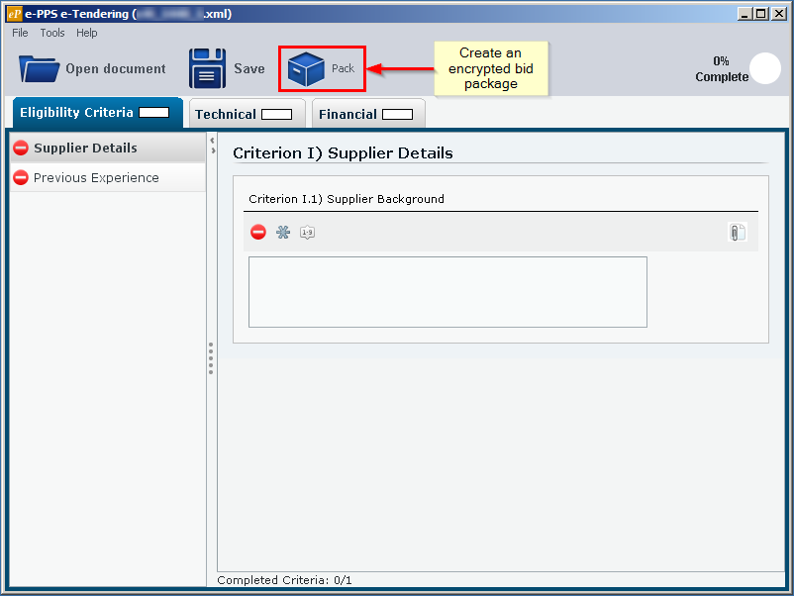

Figure 57: Offline bid preparation tool

The user then needs to return to the e-GP system to submit the bid created offline by clicking on the “Manual upload of tender package” button (Figure 55). The user will be prompted to locate and select the packed archive ending in “\_TENDER.zip” for uploading. The process is completed by clicking the “Manual Upload of Tender Package” (Figure 58).

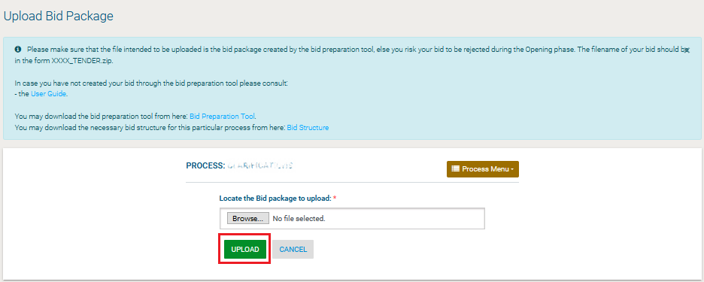

Figure 58: Upload offline bid package

## Accept Modified Provider’s Financial Value

In case the finalized value of the provider’s bid is modified by the EC users, the corresponding provider admin user will be tasked to approve the updated financial value.

Upon clicking on the relevant task available on his task list, the provider admin will be directed to a page where he will be able to approve or reject, with a mandatory reason, the financial value update.

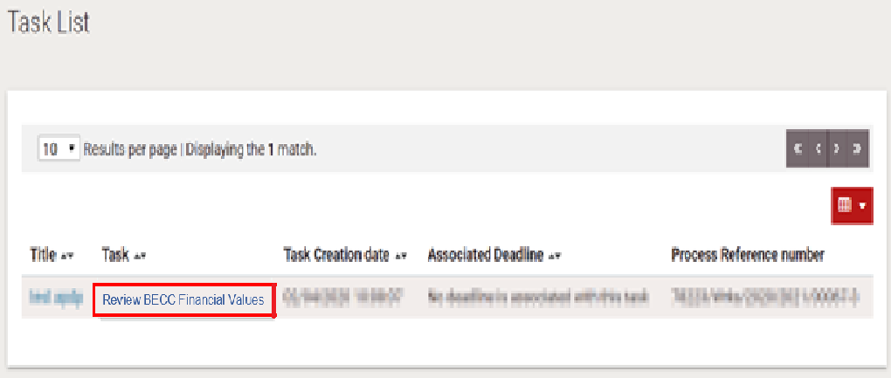

Figure 59: Review BECC Financial Values task

In case the provider admin user selects the “Accept” option, the financial value will be automatically updated.

In case the provider admin selects the “Reject” option, the financial value will not be modified and the reason for the rejection will be sent back to the BECC.

The provider will have 5 working days to respond, if not the request will be automatically rejected.

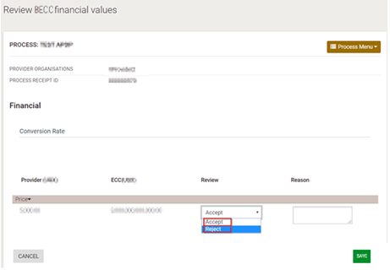

Figure 60: Accept/Reject Financial Value Update

## Postqualifications

Postqualifications are requests submitted by the Procuring and Disposing Entity in the context of a specific Process at the end of the evaluation phase. They are very similar to Evaluation Clarifications, except that they are targeted at the bidder who was ranked in first position. To preview any postqualification request the user needs to select the “Postqualifications” option found under the Process menu (Figure 61).

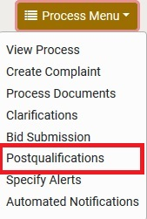

Figure 61: Postqualifications menu selection

A list of all the postqualification requests is displayed (Figure 62). The provider user must respond to all the postqualification requests by selecting the radio button and clicking on the “Answer Postqualification Request” button.

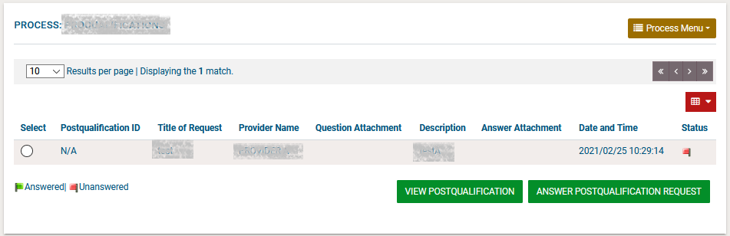

Figure 62: List of postqualification requests

The user completes the Postqualifications by providing his response in the “Postqualifications” text area. Supporting documentation can be attached. Where multiple documents need to be provided, these should be combined in a zip file.

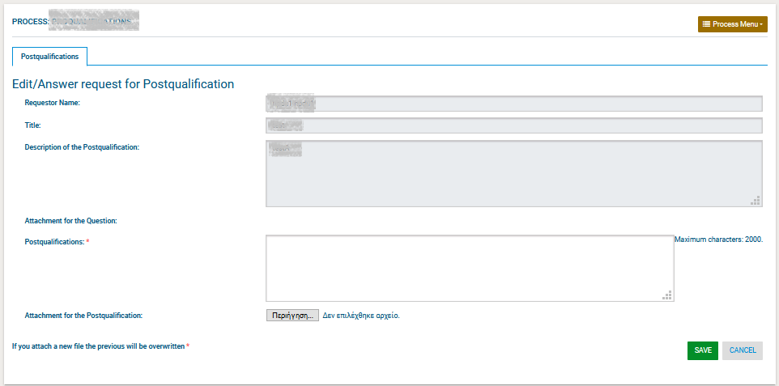

Figure 63: Respond to postqualification

## Complaints

After the publication of the BEB Notice, the provider user is able to submit a complaint regarding the actions of a specific process. These complaints are submitted by selecting the “Create Complaint” option in the Process Menu (Figure 64).

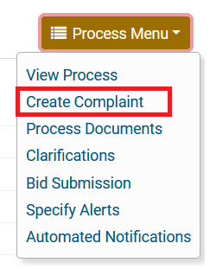

Figure 64: Complaint selection in the process menu

The provider user completes the form and sends the request to the Procuring Entity.

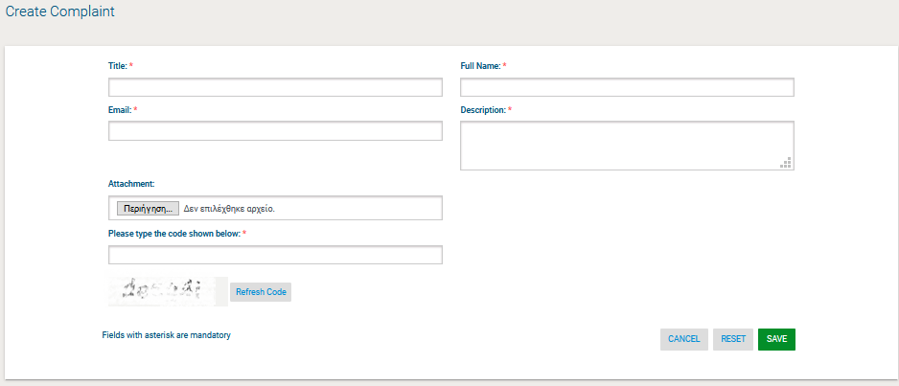

Figure 65: Submit complaint request

After the Procuring and Disposing Entity responds the request, the Provider can view the response given to the above introduced email address (Figure 66).

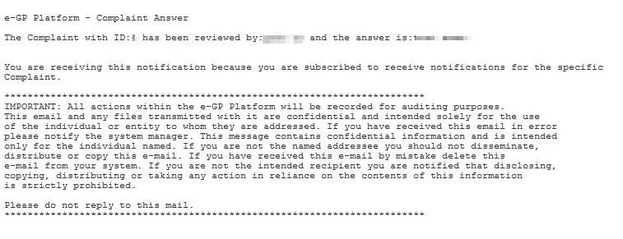

Figure 66: View complaint response

## Administrative Reviews

A provider who has submitted a complaint and is not satisfied with the response received from the procuring and disposing entity can lodge an administrative review against the process. As soon as an administrative review is lodged the process status changes to Suspended. The process workflow cannot be resumed until all administrative reviews have been finalised. The provider user must select the “Administrative reviews” menu item in the process’s menu to navigate to the respective page.

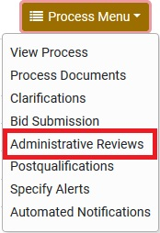

Figure 67: Administrative reviews menu selection

Before lodging the administrative review, an administrative review fee may need to be paid. The user must follow the instructions in section 2.10.2 to complete the payment. Once the payment has been successfully completed, the user is shown the screen to submit the administrative review to the Accounting Officer (Figure 68).

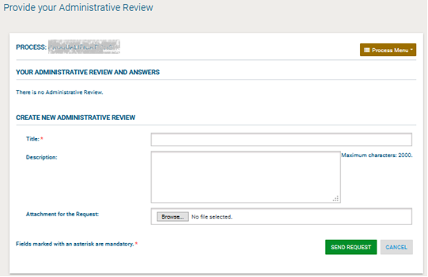

Figure 68: Submit an administrative review

The response to the administrative review is available for the provider user to view once the process is completed and the result is captured in the e-GP system. Another administrative review can only be lodged if the standstill period of the process has not elapsed. The administrative review fee needs to be paid again in order to lodge a new administrative review.

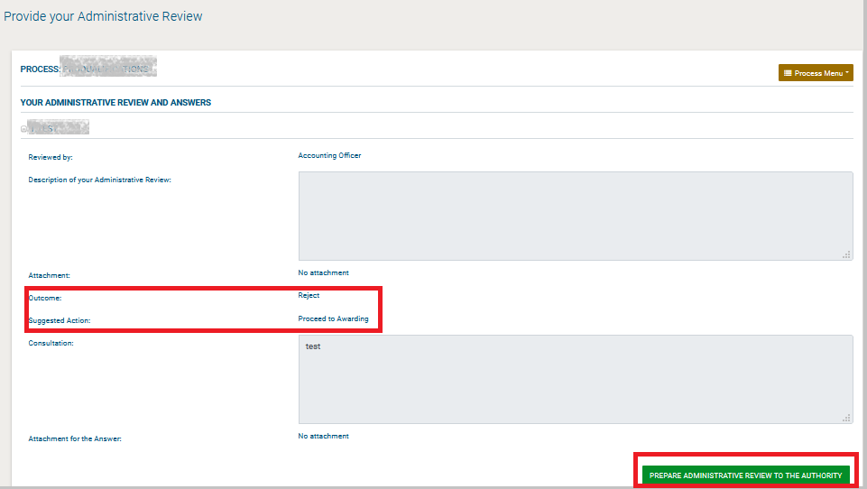

Figure 77: Response to an administrative review

After the AO submits his response a new task will be available to the provider, in order to view the details of his complaint to the Accounting Officer.

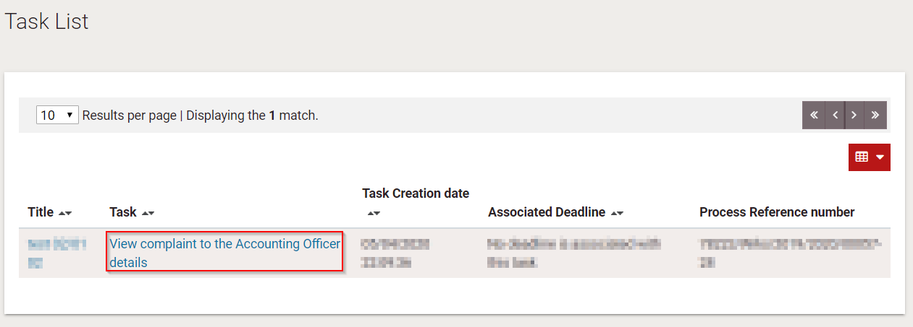

Figure 69: Provider’s task list- View complaint details

If the provider is not pleased with the AO’s answer, they can send an administrative review to the Authority.

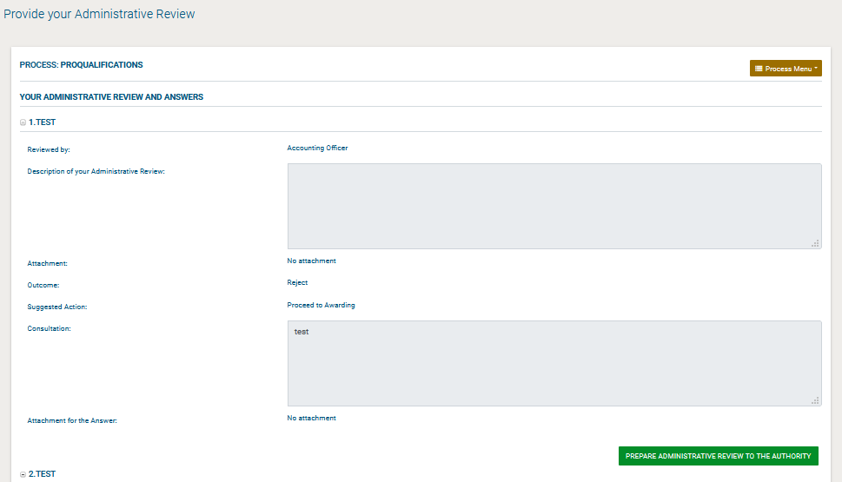

Figure 70: Prepare Administartive review to the Authority(Nigeria States)

After the AO submits his response a new task will be available to the provider, in order to view the details of his complaint to the Accounting Officer of the State

If the provider is not pleased with the AO’s answer, he can send an appeal to the Tribunal, by clicking on the “Administrative Reviews” option under the Process menu.

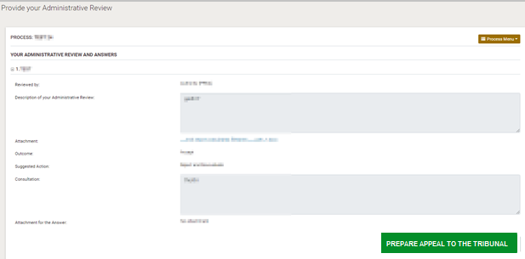

Figure 71: Prepare Appeal to Tribunal

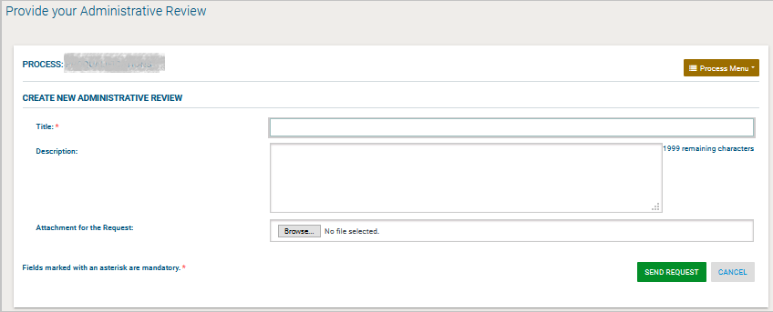

Figure 72: Send Appeal to Tribunal

Following an appeal submission, the Process proceedings will be suspended and the status of the Process will change to “Suspended”.

After the Appeal Tribunal user saves as “Official” his administrative review response and the PC user selects the final outcome, the Provider will have a new task to “View Administrative Review Outcome”.

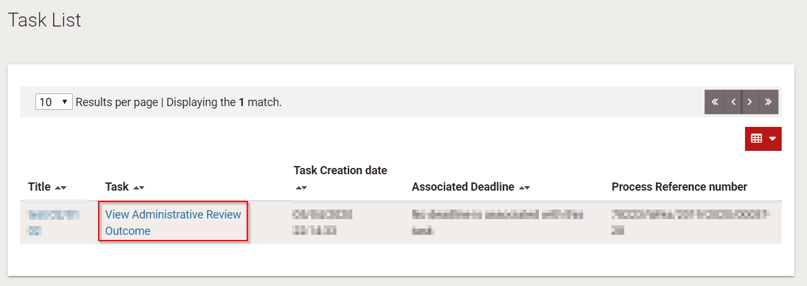

Figure 73: Provider’s task list – View Administrative Review Outcome

## E-Auctions

### Participation in an e-Auction Event

In order to respond to the e-Auction invitation the bidder needs to select the task “**Respond to the e-Auction Invitation**” in his task list (Figure 74).

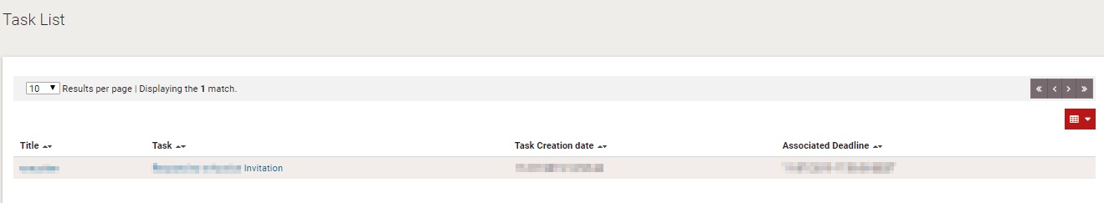

Figure 74: Respond to an e-Auction invitation

The user has the option to “Accept to participate in the e-Auction event” (**Error! Reference source not found.**) or to “Decline to participate in the e-Auction event” (**Error! Reference source not found.**). The system informs the user regarding acceptance (Figure 75) / rejection (Figure 77) decision.

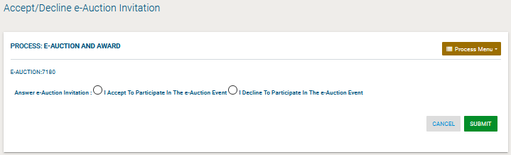

Figure 75: Accept an invitation to participate in an e-Auction event

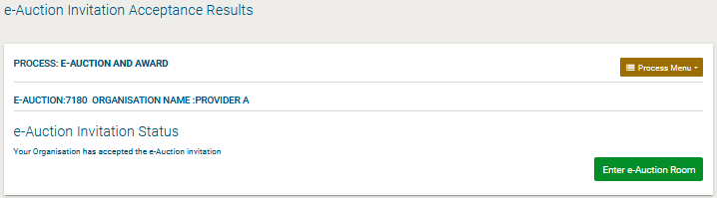

Figure 76: Accept an invitation to participate in the e-Auction event

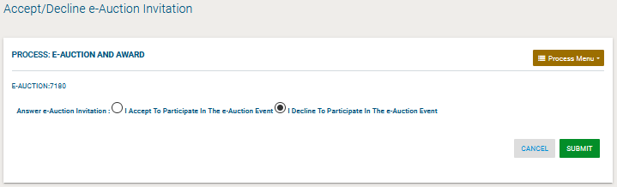

Figure 77: Decline an invitation to participate in the e-Auction event

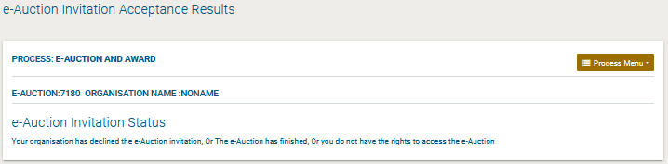

Figure 78: e-Auction invitation acceptance results (declined invitation)

|  |  |
| --- | --- |
| Warning | It is important the bidder to accept the invitation at least 30 minutes before the e-Auction start date, else he will not be able to accept the invitation and participate in the e-Auction event. The start date of the auction is available in the Auction’s details. |

In order to participate in the auction event, the bidder needs to enter the e-Auction room. This functionality is accessible from the “**e-Auctions**” option of the **Menu (**Figure 79Error! Reference source not found.**).**

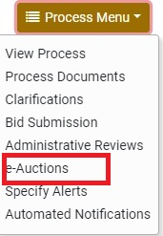

Figure 79: Menu, option “e-Auctions”

A list with all e-Auction events scheduled for the particular Process will be displayed to the user (Figure 80). For each Lot contained in the Process a separate e-Auction event will be held. The list contains detailed information regarding the event. In particular, the system allows to display information such as the type of event, whether the event is official or practice and the starting date for the event.

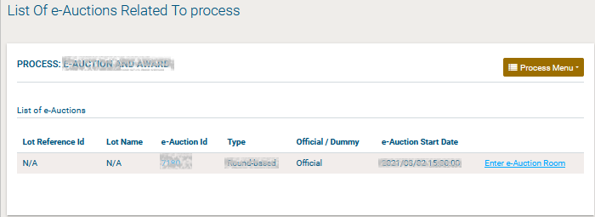

Figure 80: List of e-Auctions related to the CfT

Selecting the “**e-Auction Id**” allows the user to preview all details of the event (Figure 81) while selecting the link “**Enter e-Auction Room**” allows the user to enter the e-Auction room which provides all the bidding functionality (Figure 81).

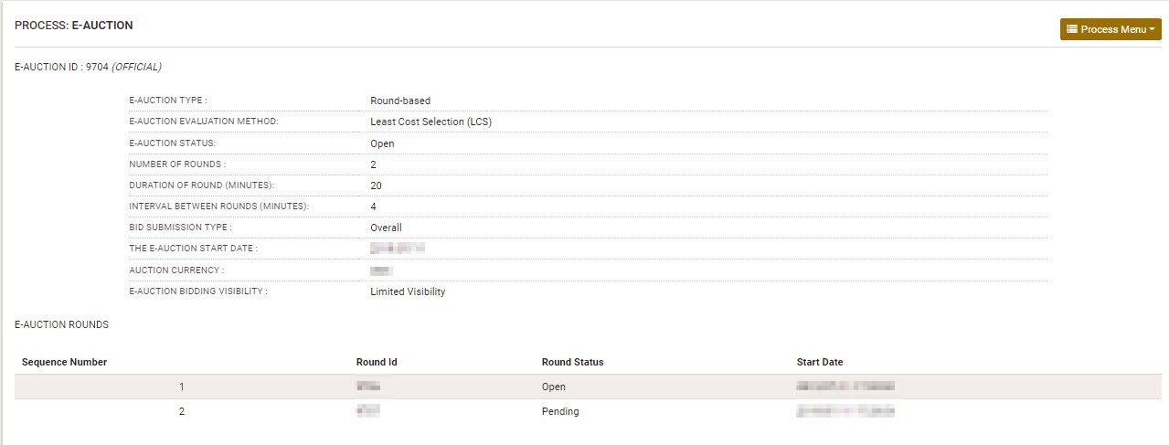

Figure 81: Detailed information regarding the e-Auction event

### Submission of an Offer

There are two kinds of events:

Forward (Disposal) Auctions

Reverse Auctions

Also, the system supports the three following types of events:

• Round based

• Time based

• Combination

Access to the e-Auction room will be enabled only at the commencement date and time specified for the event. The user needs to select the button “**Enter e-Auction Room**” to access the e-Auction room.

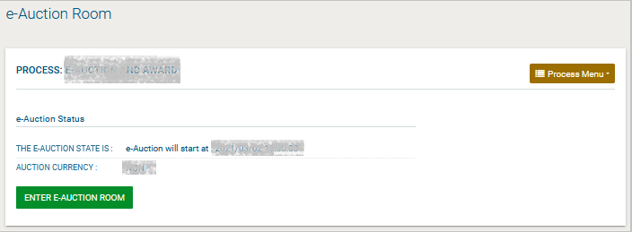

Figure 82: e-Auction status

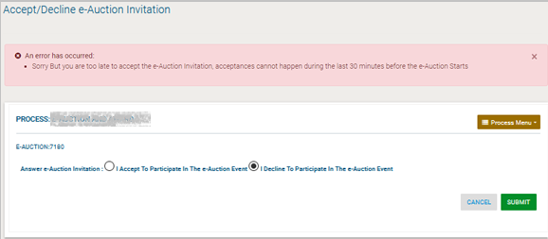

Figure 83: Unable to attend e-Auction

The e-Auction room provides all functionalities for placing a bid for events containing financial criteria.

In both cases the bidder can visualize the following information at the top of the page (Figure 84):

The e-Auction state (status, round, etc.)

The e-Auction currency

Time Left To the End Of The Round

Minimum Bid Difference

Auction Currency

View Current Bid Details

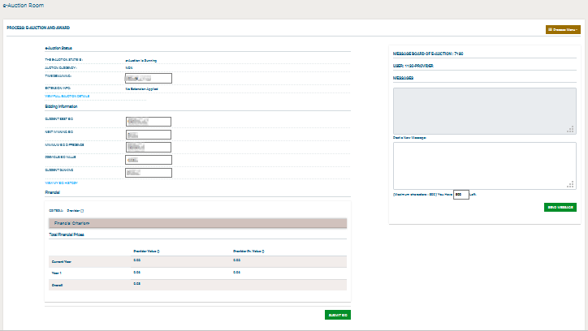

Figure 84: e-Auction room, main information regarding the e-Auction

### Placing a bid in e-Auctions

The user provides his financial bid in all participating criteria and then selects the button “**Submit**” to submit the bid in the system.

Figure 88: Submit a Lowest Price bid

In addition to the information described in Figure 84, the following information (Bidding Information) fields are displayed in the e-Auction:

CURRENT BEST BID

NEXT WINNING BID

MINIMUM BID DIFFERENCE

PREVIOUS BID VALUE

CURRENT RANKING

VIEW MY BID HISTORY

VIEW LATEST BID FROM ALL PARTICIPANTS

VIEW BID HISTORY FROM ALL PARTICIPANTS

The section “**User**” provides ranking information during the bidding process. The displayed information depends on the e-Auction visibility criteria which are specified by the e-Auction Coordinator.

The system prompts the user to confirm the submission of his bid. The message contains all details regarding the particular bid. Selecting the button “**OK**” will submit the bid in the platform while, the button “**Cancel**” will cancel the operation.

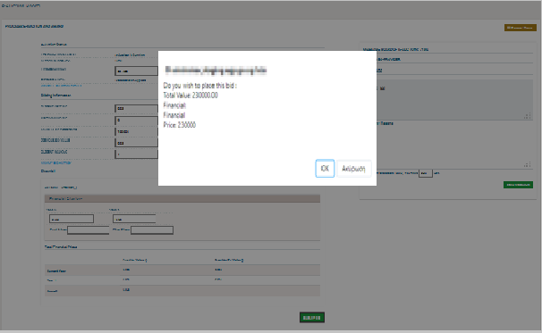

Figure 85: Confirm submission of bid

If the bid is valid, an acceptance message will be displayed (**Error! Reference source not found.**). The acceptance message contains the unique “**Bid Receipt Id**” and the unique “**Bid Hash**”.

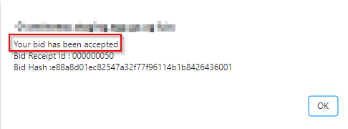

Figure 86: Acceptance message

If the bid is not valid, an error message will be displayed to the user (Figure 87). The error message will describe why the bid has not been registered in the system.

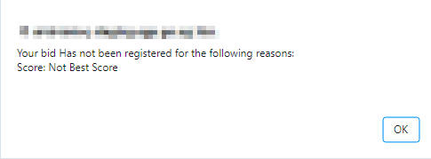

Figure 87: Bid has been rejected

Depending on the bid visibility option, the user can view a list with:

All the bids submitted by him

The latest bid from all participants

The bids submitted by all participants

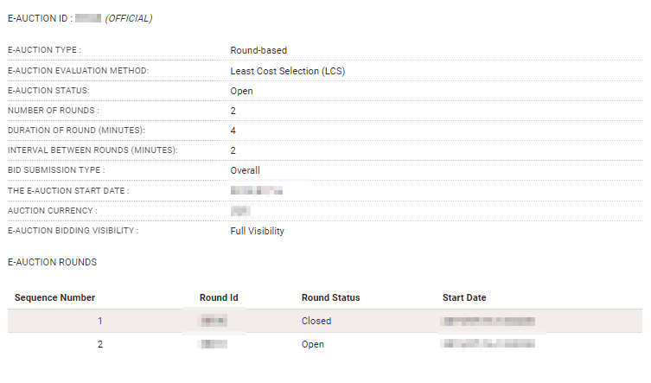

Figure 88: Finalized Bids

### Extensions

Automated extensions are enabled by the e-Auction Coordinator during the creation of the e-Auction Time Based event.

Information regarding the use of automated extensions is available for the user when previewing the detailed information of the e-Auction event.

In order for the user to create a Time based event, the following information must be provided:

Duration of e-Auction event

Enable Automated Extensions

Duration of Extension

Time before the of e-Auction when extension is possible

Maximum number of automated extensions

During the bidding process, the user previews if an extension has been applied.

When an extension is applied, the platform displays the extension number and end time and date of the extension.

### Message Board

The e-Auction module provides a message board functionality for the prompt communication between Bidders and the Co-ordinator of the e-Auction (**Error! Reference source not found.**).

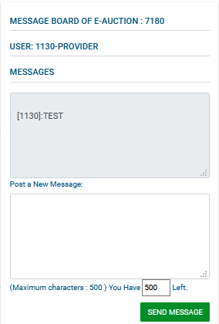

Figure 89: e-Auction message board

The upper part of the message board displays all messages posted by participating Bidders and also the messages/replies posted by the e-Auction Administrator.

In order to post a message the user fills the “**Post a new message**” section and then, selects the button “**Send Message**” to post the message on the board (Figure 89).

### Suspension of an e-Auction Event

When the event is suspended no further bidding is permitted (during the suspension period). The platform informs all participating Bidders that the event is suspended and also when the event will resume. When the event is resumed, the user needs to select the button “**Enter e-Auction Room**” to access the e-Auction room and to continue bidding.

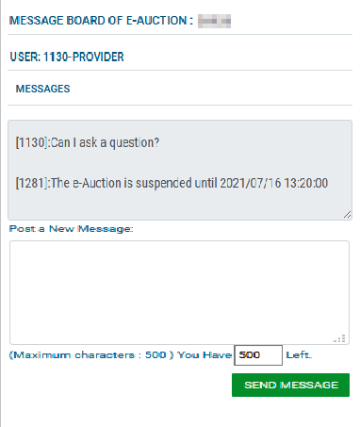

Figure 90: e-Auction is suspended

### Preview of a Completed e-Auction

At the end of the e-Auction, the platform will display the auction detailed information (Figure 91).

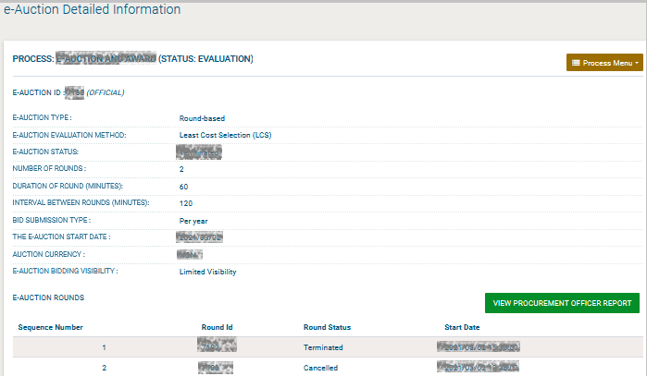

Figure 91: e-Auction detailed information

In order to view the bidding results the user needs to select the button “**View provider Report**” (Figure 95).

The platform will provide the following information to participating Bidder (Figure 93):

Winning bid of the e-Auction

Ranking of the Bidder

Best bid of the bidder

Detailed information for all received bids from the Bidder

Ranking information per round

Several e-Auction charts (Figure 94 and Figure 95)

Bid details

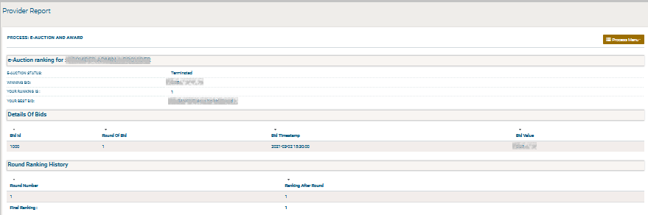

Figure 92: Bid information general (1)

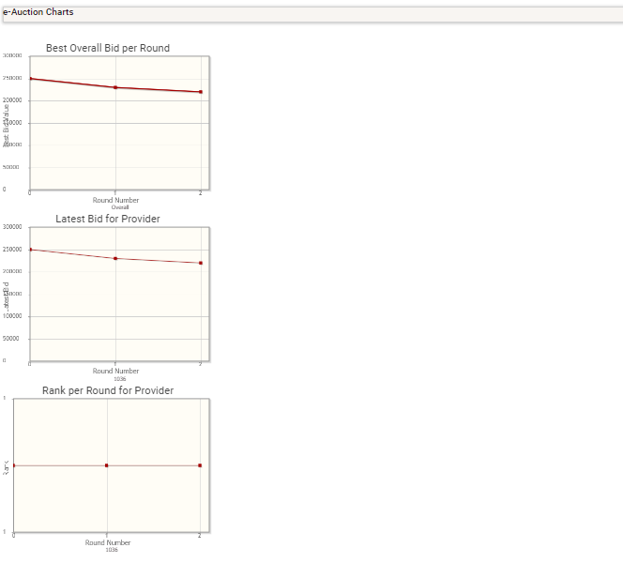

Figure 93: Bid information general (2)

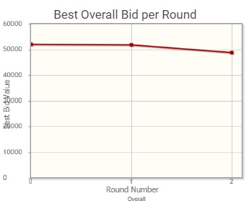

Figure 94: Best Overall Bid per Round

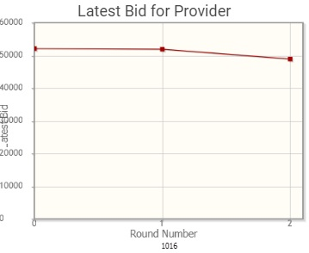

Figure 95: Latest bid for Provider

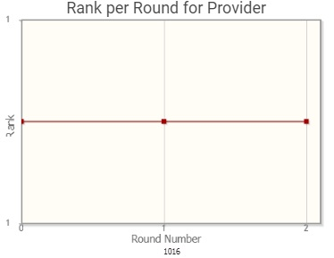

Figure 96: Rank per Round for Provider

## Accept Contract

The Provider Admin will be tasked to Approve or Reject the Draft Contract, with a mandatory reason.

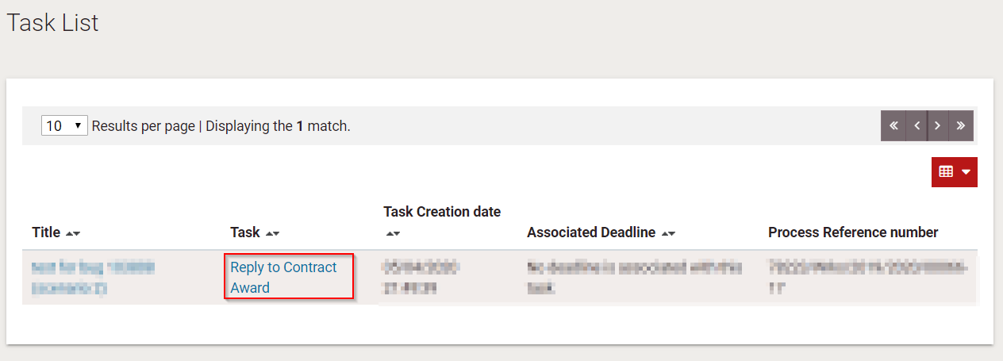

Figure 97: Reply to Contract Award task

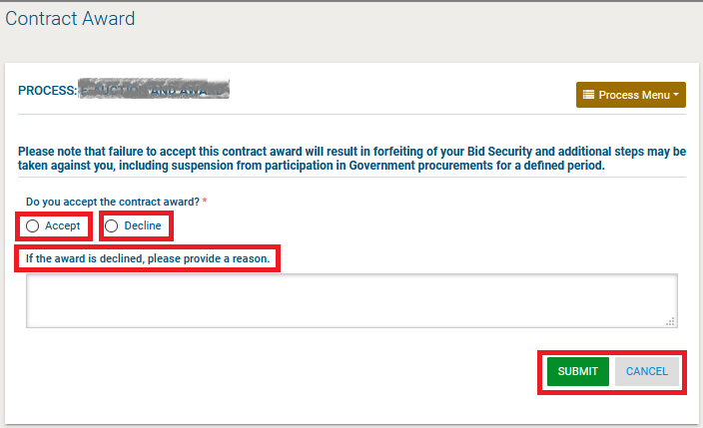

Figure 98: Accept/Decline Contract Award

## Helpdesk Contact Details

To contact the e-GP helpdesk you may visit the “Contact Us” link.

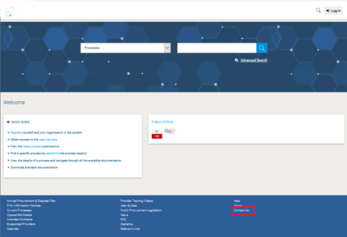s

Figure 99: Contact us link

The user may either select to fill in an online form and send it through the system, or directly contact the helpdesk team via phone or email.

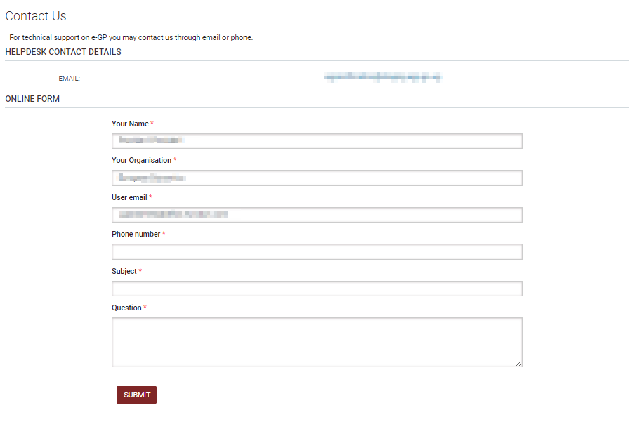

Figure 100: Contact us form